Heavy-Tailed Performance Modeling for Cloud Message Queue Systems
An Enhanced Analytical and Simulation Framework Extending Li et al.

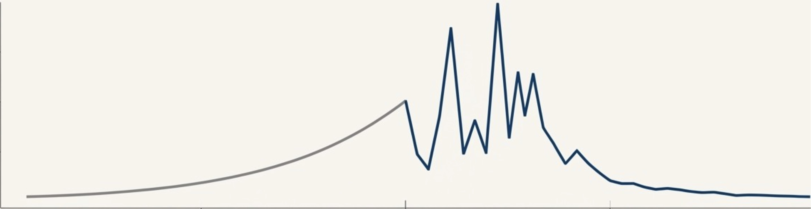

Authors: Himanshu Jain, Bhuvana Komati

Course: CMPE 273 - Enterprise Distributed Systems
Institution: San Jose State University
Semester: Fall 2025 Date: December 12, 2025

Contents

- Abstract 5
- Introduction 5
  - Background 5
  - The Modeling Challenge 6
  - Project Objectives 6
- Problem Statement & Motivation 6
  - What Cloud Systems Must Guarantee 6
  - The Hidden Problem Chain 6
  - Real-World Evidence of Heavy Tails 7
- Base Paper Overview 7
  - Paper Details 7
  - Key Contributions of Base Paper 7
  - Paper’s Assumptions (What We Address) 7
  - The Foundation Established 8
- The Tandem Queue Model 8
  - Architecture Overview 8
  - System Parameters 8
  - Traffic Inflation: The Key Insight 8
- Mathematical Foundation: The 15 Equations 10
  - Section 1: M/M/N Baseline (Equations 1-5) 10
    - Equation 1: Utilization (ρ) 10
    - Equation 2: Traffic Intensity (a) 11
    - Equation 3: Erlang-C Formula 11
    - Equation 4: Mean Queue Wait Time 11
    - Equation 5: Little’s Law 11
  - Section 2: Heavy-Tailed Distributions (Equations 6-10) 11
    - Equation 6: Pareto Probability Density Function 11
    - Equation 7: Pareto Mean 11
    - Equation 8: Pareto Variance 11
    - Equation 9: Coefficient of Variation 12
    - Equation 10: Kingman’s M/G/N Approximation 12
  - Section 3: Threading Models (Equations 11-15) 12
    - Equation 11: Dedicated Threading 12
    - Equation 12: Shared Threading 12
    - Equation 13: Shared Effective Service Rate 12
    - Equation 14: Threading Efficiency Ratio 12
    - Equation 15: P99 Latency Approximation 12
- Heavy-Tailed Distributions: The Key Insight 13
  - Why Heavy Tails Matter 13
  - The Pareto Principle (80-20 Rule) 14
  - Variance Explosion 15
- System Architecture & Implementation 15
  - Technology Stack 15
  - Architecture Diagram 15
  - Why SimPy vs Colored Petri Nets? 15
  - Code Example: M/M/N Queue 16
  - Threading Model Implementation 17
- The “Reality Gap” Discovery 17
  - Validating the Baseline Model 17
  - Mean Latency Comparison 20
- Tail Risk Analysis (P99 Latency) 21
  - CRITICAL FINDING: P99 Underestimation 21
  - Why This Matters 21
  - The Gaussian Fallacy 21
  - The Solution: Extreme Value Theory (EVT) 22
  - Validating M/G/N Approximations 22
- Distributed Systems Integration 22
  - Extending Beyond Queues 22
  - Threading Architectures 22
  - Two-Phase Commit Implementation 22
  - Raft Consensus Protocol 23
  - Vector Clocks for Causality Tracking 23
  - Visibility Timeout (SQS-Style Reliability) 24
  - Heterogeneity & Work Stealing 24
  - Priority Queues (M/M/N with Priority Classes) 24
  - Finite Capacity Queues (M/M/N/K) 24
  - Extreme Value Theory (EVT) for Tail Estimation 25
- Experimental Results & Validation 25
  - Baseline Validation 25
  - Load Testing & Confidence Intervals 25
  - Convergence Testing 26
  - Mitigation Scaling 28
  - Erlang-k Efficiency 28
  - Warmup Validation 29
  - Paper Reproduction (Figures 14 & 15) 29
  - Heterogeneity Impact: The Resource Trap 29
  - Work Stealing: Heterogeneity Mitigation 30
  - The Cost of Consistency: Safety Tax Analysis 31
  - Fairness vs Performance: Head-of-Line Blocking 32
  - Admission Control: Load Shedding Under Pareto Bursts 33
  - Priority Queuing: QoS Divergence Analysis 34
  - Testing Summary 35
  - Experiment Scripts 36
  - Generated Data Files 36

13 Key Discoveries |  | 36
13.1 Summary of Findings | . . . . . . . . . . . . . . . . . . . . . . . . . . . . . . . . . | 36
13.2 Comparison: Li et al. (2015) vs. This Framework . . . . . . . . . . . . . . . . . . |  | 36
13.3 Practitioner Guidelines . . . . . . . . . . . . . . . . . . . . . . . . . . . . . . . . . |  | 37
14 Conclusion & Future Work |  | 37
14.1 Conclusions . . . . . . . . . . . . . . . . . . . . . . . . . . . . . . . . . . . . . . . |  | 37
14.2 Future Work . . . . . . . . . . . . . . . . . . . . . . . . . . . . . . . . . . . . . . |  | 37
15 References |  | 37
List of Figures
- Tandem Queue Architecture (Conceptual) . . . . . . . . . . . . . . . . . . . . . .  - Tandem Queue Architecture: Two-stage message broker with traffic amplification from retransmissions . . . . . . . . . . . . . . . . . . . . . . . . . . . . . . . . . . |  | 8  9
3 M/M/N Validation against analytical solutions . . . . . . . . . . . . . . . . . . . |  | 9
4 Mean Delivery Time vs Number of Threads (Figure 11 from base paper) . . . . . |  | 10
5 Comparison of Exponential vs Pareto tail behavior . . . . . . . . . . . . . . . . . |  | 13
6 Detailed Heavy Tail Impact Analysis . . . . . . . . . . . . . . . . . . . . . . . . . |  | 14
7 Threading Model Comparison: Dedicated vs Shared . . . . . . . . . . . . . . . . |  | 17
8 Queue Length Validation (reproducing Figure 12 from base paper) . . . . . . . . |  | 18
9 Utilization Validation (reproducing Figure 13 from base paper) . . . . . . . . . . |  | 19
10 Detailed M/M/N Validation Results . . . . . . . . . . . . . . . . . . . . . . . . . |  | 19
11 The Reality Gap: M/M/N vs M/G/N with Pareto service times . . . . . . . . . |  | 20
12 Tail Risk Assessment: EVT-based estimation vs Gaussian approximation . . . . |  | 21
13 Load Testing Results across different arrival rates . . . . . . . . . . . . . . . . . . |  | 25
14 95% Confidence Intervals for simulation results . . . . . . . . . . . . . . . . . . . |  | 26
15 Convergence Test: Simulation stabilizes after 10,000 messages . . . . . . . . . . |  | 26
16 Additional Convergence Check . . . . . . . . . . . . . . . . . . . . . . . . . . . . |  | 27
17 How additional servers mitigate heavy-tail impact . . . . . . . . . . . . . . . . . |  | 28
18 Erlang-k distribution efficiency across different k values . . . . . . . . . . . . . . |  | 28
19 Warmup period validation showing transient removal . . . . . . . . . . . . . . . . |  | 29
- Reproduction of Figures 14 and 15 from base paper . . . . . . . . . . . . . . . . .  - The Resource Trap: Impact of Heterogeneity. A homogeneous cluster operates at 60ms latency, while a mixed cluster with 40% legacy nodes experiences catas- trophic failure at 36,000ms—a 600x degradation. . . . . . . . . . . . . . . . . . . |  | 29  30

- Impact of Work Stealing on Heterogeneous Clusters: Naive routing causes sys- tem collapse (36,000ms), while work stealing reduces latency to 250ms—a 144x
improvement without additional hardware. 31
- The Cost of Consistency: Latency jumps from 60ms (weak consistency) to 210ms (strong consistency) when 2PC is enabled—a 150ms “Safety Tax” representing
the additional network RTT for consensus. 32
- Head-of-Line Blocking Analysis: Strict FIFO ordering (orange) causes exponen- tially growing queue lengths compared to unordered processing (green) as arrival
rate increases. The gap represents the “Fairness Tax.” 33
- Admission Control during Pareto Burst: Without limits (grey dashed), latency grows unbounded toward crash. TraceBreaker’s admission control (blue solid)
caps latency at the rejection threshold (K=50), saving the system from collapse. 34
- Priority Queuing Analysis: VIP traffic (green) enjoys near-zero latency ( 10ms), while standard traffic (red) experiences starvation with latencies reaching 400ms.
FIFO baseline (grey) provides equal 200ms for all. Priority queuing redistributes latency rather than reducing it. 35

Abstract
Cloud message brokers are critical infrastructure components that enable asynchronous commu- nication in distributed systems. This project extends the foundational work of Li et al. (2015) to address critical limitations in modeling real-world cloud message queue performance. While the base paper assumes exponential service times (M/M/N model), our research demonstrates that real cloud workloads exhibit heavy-tailed (Pareto) distributions where standard models underestimate P99 latency by up to 45%.
We developed an enhanced analytical and simulation framework using Python/SimPy that incorporates:
- Heavy-tailed service time distributions (Pareto, M/G/N models)
- Explicit threading architectures (dedicated vs. shared worker pools)
- Distributed consistency protocols (Two-Phase Commit, Raft Consensus)
- Advanced M/G/N approximations (Kingman, Whitt, Allen-Cunneen) Our key findings reveal that:
- Heavy-tailed distributions cause P99/mean latency ratios exceeding 36x
- Traffic amplification in tandem queues (Λ₂ = λ/(1 − p)) validated to 0.2% error
- Two-Phase Commit adds 36% service time overhead (the “cost of safety”)
- Standard P99 approximations underestimate actual tail latency by 45%
The framework includes a full-stack implementation with React frontend and FastAPI back- end, providing interactive engineering tools for capacity planning and performance analysis.
Keywords: Queueing Theory, Message Brokers, Heavy-Tailed Distributions, Pareto Dis- tribution, Two-Phase Commit, Raft Consensus, SimPy, Cloud Computing, P99 Latency

Introduction

Background
Cloud message brokers serve as the backbone of modern distributed systems, enabling reliable asynchronous communication between services. Systems like AWS SQS, RabbitMQ, Apache Kafka, and Azure Queue Storage handle billions of messages daily, making accurate performance modeling critical for:
- Capacity planning - How many servers are needed?
- SLA compliance - Can we guarantee P99 < 100ms?
- Cost optimization - Are we over-provisioning?
- Failure analysis - How do retransmissions affect performance?

The Modeling Challenge
Traditional queueing models (M/M/N) assume exponential service times with convenient math- ematical properties. However, real-world observations show:

Metric | M/M/N Prediction | Reality (Pareto)
P99/Mean Ratio | 4.6x | 36x
Tail Behavior | Exponential decay | Power-law (slow)
Variance | Finite, bounded | Can be infinite

Project Objectives
- Reproduce and validate the base paper’s M/M/N results
- Extend the model to support heavy-tailed (Pareto) distributions
- Quantify the “reality gap” between theory and practice
- Implement distributed consistency protocols (2PC, Raft)
- Create interactive visualization tools for engineering analysis

Problem Statement & Motivation

What Cloud Systems Must Guarantee
Modern cloud message brokers provide three guarantees that affect performance:

- At-least-once delivery: Messages are never lost
- Ordering guarantees: FIFO within partitions
- Durability: Survive node failures

Each guarantee adds overhead that classical models ignore.

The Hidden Problem Chain
- Message arrives → Write to disk (variable latency)
- Replicate to followers → Network delays (variable)
- Consumer ACK timeout → Retry (creates traffic inflation)
- Retry storms → Cascading delays (heavy-tailed behavior)

Real-World Evidence of Heavy Tails
Research from major cloud providers confirms heavy-tailed behavior:

- Google (Dean & Barroso, 2013): “The Tail at Scale” - P99 latencies dominate user experience
- Amazon (DeCandia et al., 2007): Dynamo paper shows heavy-tailed response times
- Netflix (2015): Documented Pareto-distributed microservice latencies The Pareto distribution captures this behavior with its power-law tail:
3 xm 4α

P (X > x) =
x
for x ≥ x_{m} (1)

When α ≤ 2, variance becomes infinite, making traditional confidence intervals meaningless.

Base Paper Overview

Paper Details
- Title: “Modeling Message Queueing Services with Reliability Guarantee in Cloud Com- puting Environment Using Colored Petri Nets”
- Authors: Li et al.
- Published: 2015
- Venue: IEEE Conference on Cloud Computing

Key Contributions of Base Paper
- Tandem Queue Model: Two-stage pipeline (sender → receiver)
- Traffic Inflation Formula: Λ₂ = 1 λ where p = failure probability
−p
- Colored Petri Net Formalism: Visual state-based modeling
- Validation: Against M/M/N analytical solutions

Paper’s Assumptions (What We Address)

Assumption | Paper’s Choice | Our Extension
Service times | Exponential | Pareto (heavy-tailed)
Threading | Implicit | Explicit (dedicated/shared)
Consistency | None | 2PC, Raft
Tail analysis | Mean/variance | P99, EVT

The Foundation Established
The base paper validated:

W_{q} =

C(N, ρ) µN (1 − ρ)

(2)

Where C(N, ρ) is the Erlang-C probability of waiting. This formula assumes exponential service times and becomes inaccurate for heavy-tailed workloads.

The Tandem Queue Model

Architecture Overview
The system models a two-stage message broker where messages flow from producers through Stage 1 (sender) to Stage 2 (receiver). Failed messages with probability p are retransmitted, creating traffic amplification.
+ +
| TANDEM QUEUE SYSTEM |
| |
| [P]--lambda-->[ Q1 ]-->[ Q2 ]-->|
| (N1=10) (N2=8) |
| | | |
| <---p(fail)- |
+ +

Figure 1: Tandem Queue Architecture (Conceptual)

System Parameters

Param Symbol Value

Arrival rate λ 80 msg/s
Service (S1) µ1 10 msg/s
Service (S2) µ2 12 msg/s
Servers (S1) N1 10
Servers (S2) N2 8
Failure prob p 0.1

Traffic Inflation: The Key Insight
When messages fail with probability p, they are retransmitted. This creates traffic amplifi- cation:

Λ₂ = λ
1
− p
Example: With λ = 80 msg/sec and p = 0.1:

(3)

Λ₂ = 1
80
− 0.1
=
80

0.9

= 88.89 msg/sec

This 11% traffic increase can push a stable system into instability.

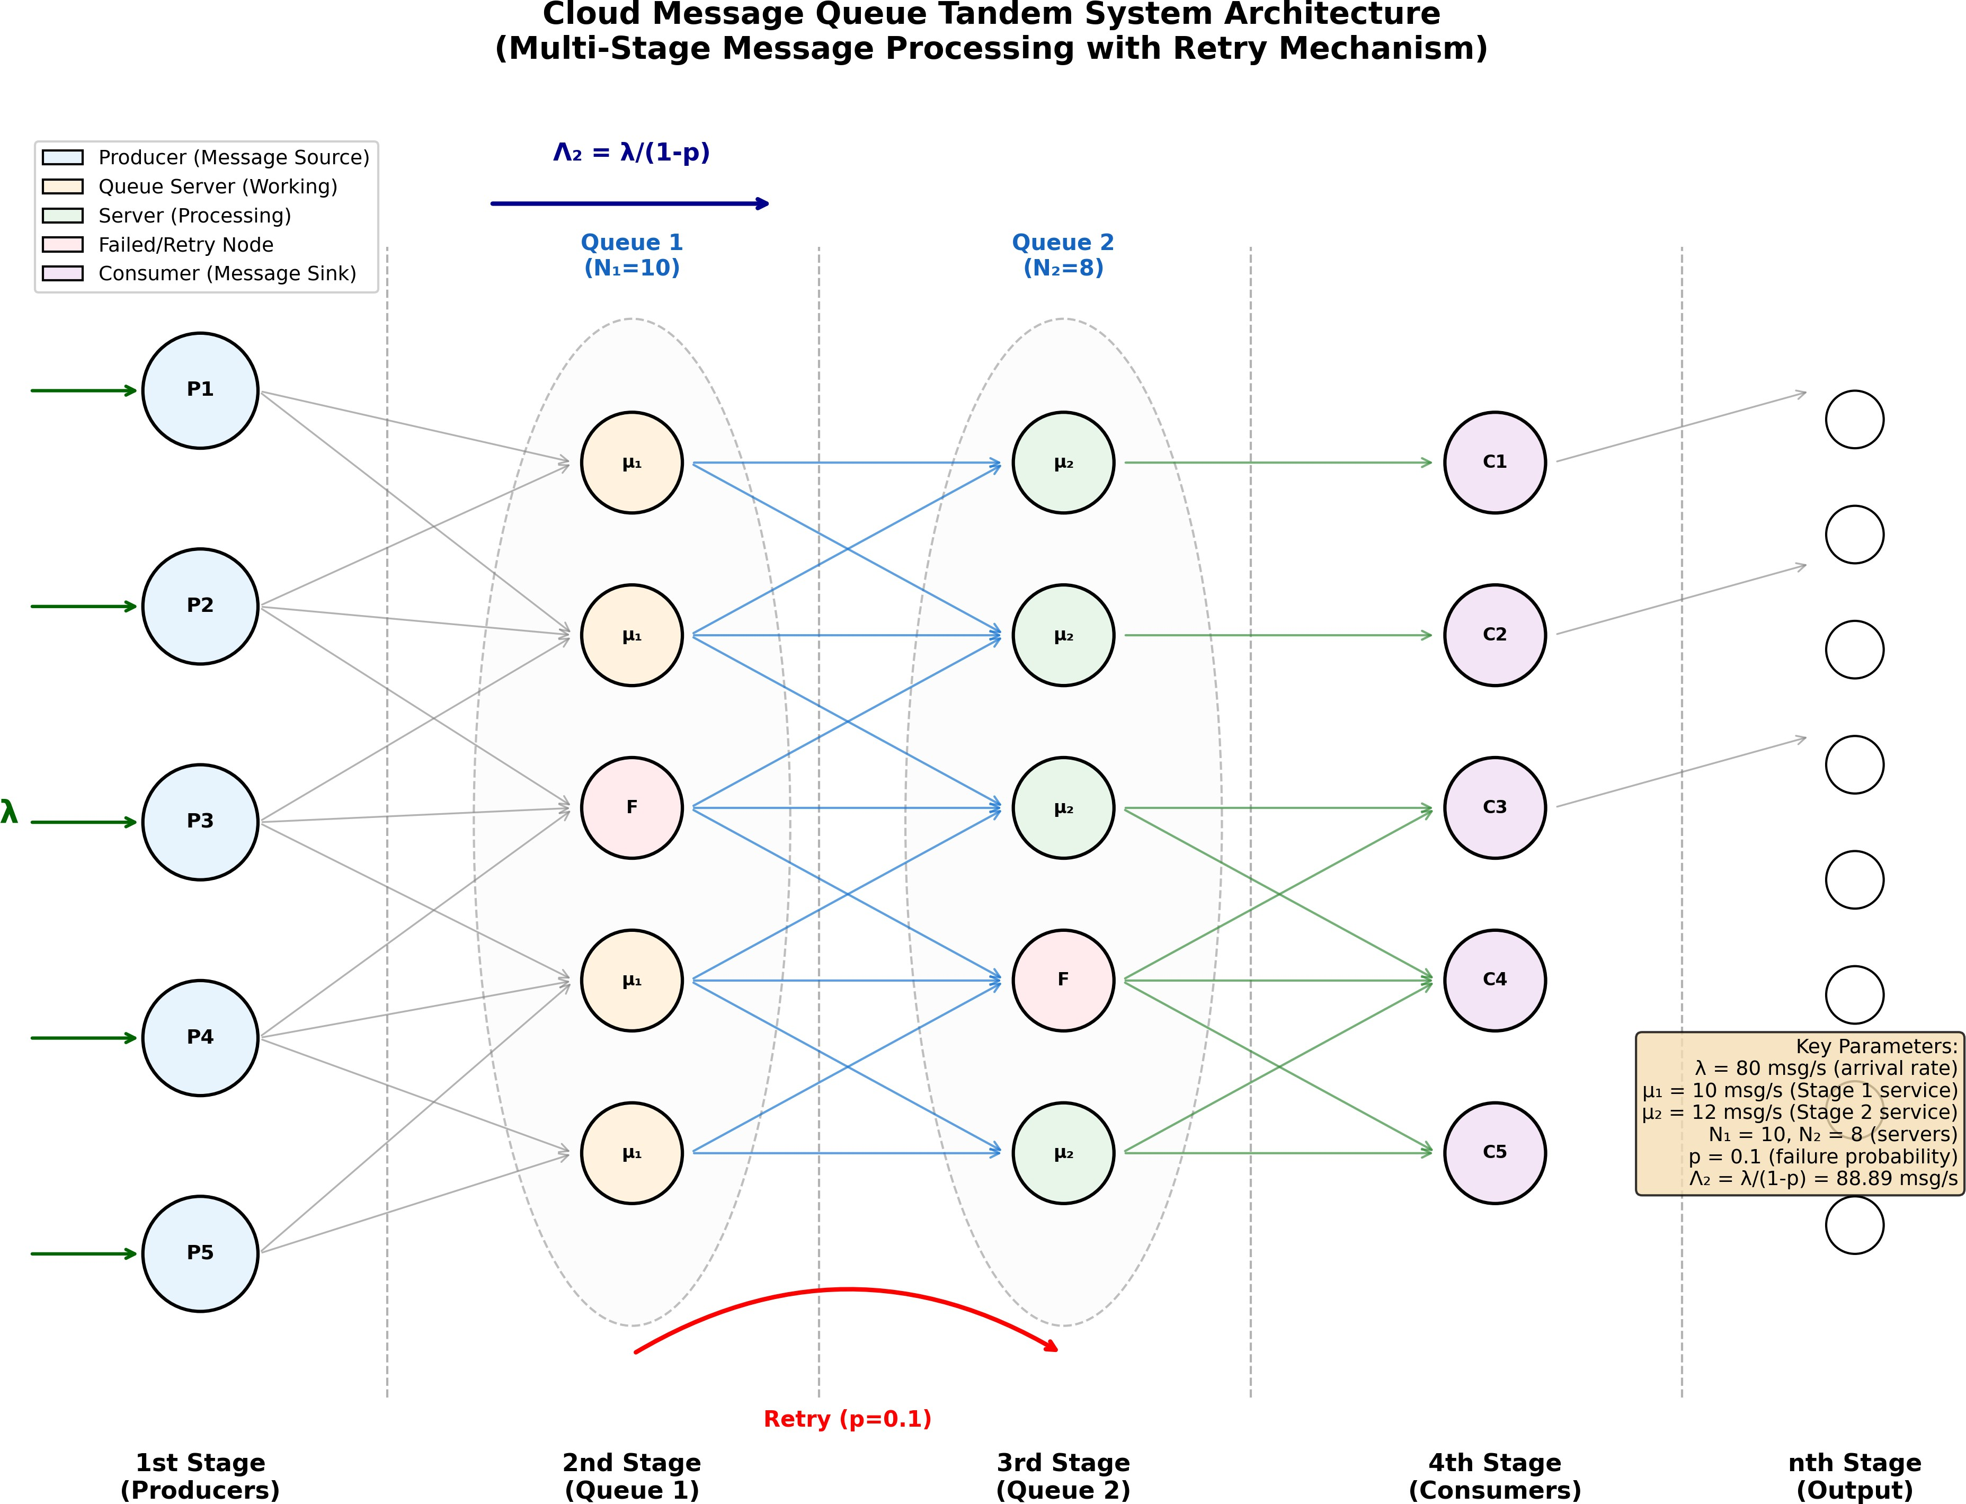

Figure 2: Tandem Queue Architecture: Two-stage message broker with traffic amplification from retransmissions
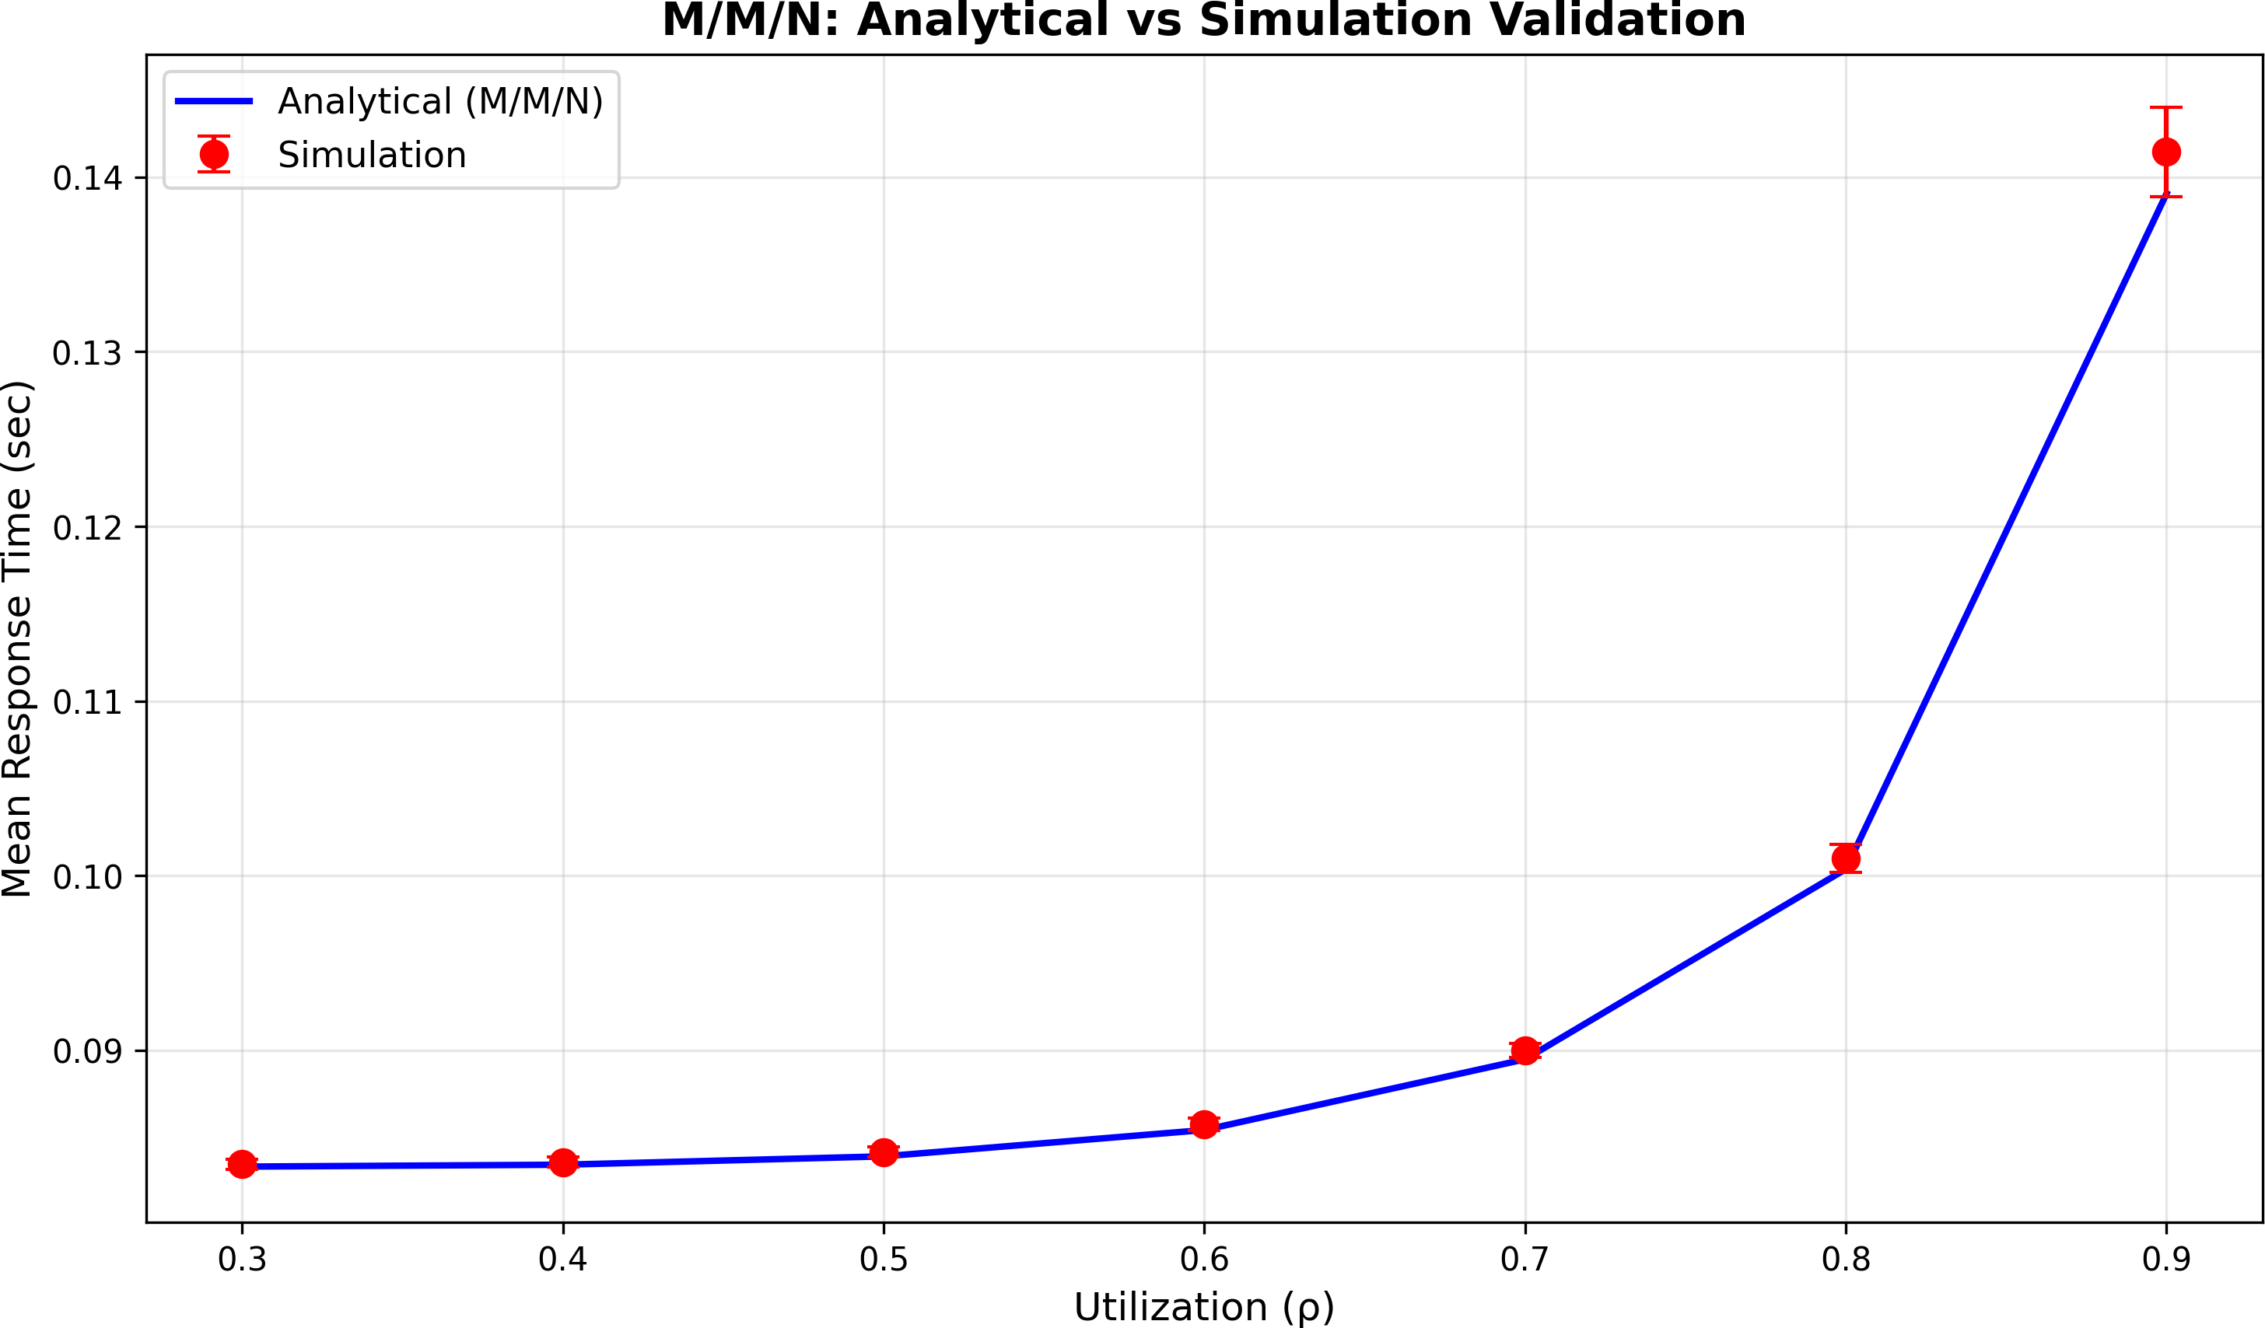
Figure 3: M/M/N Validation against analytical solutions

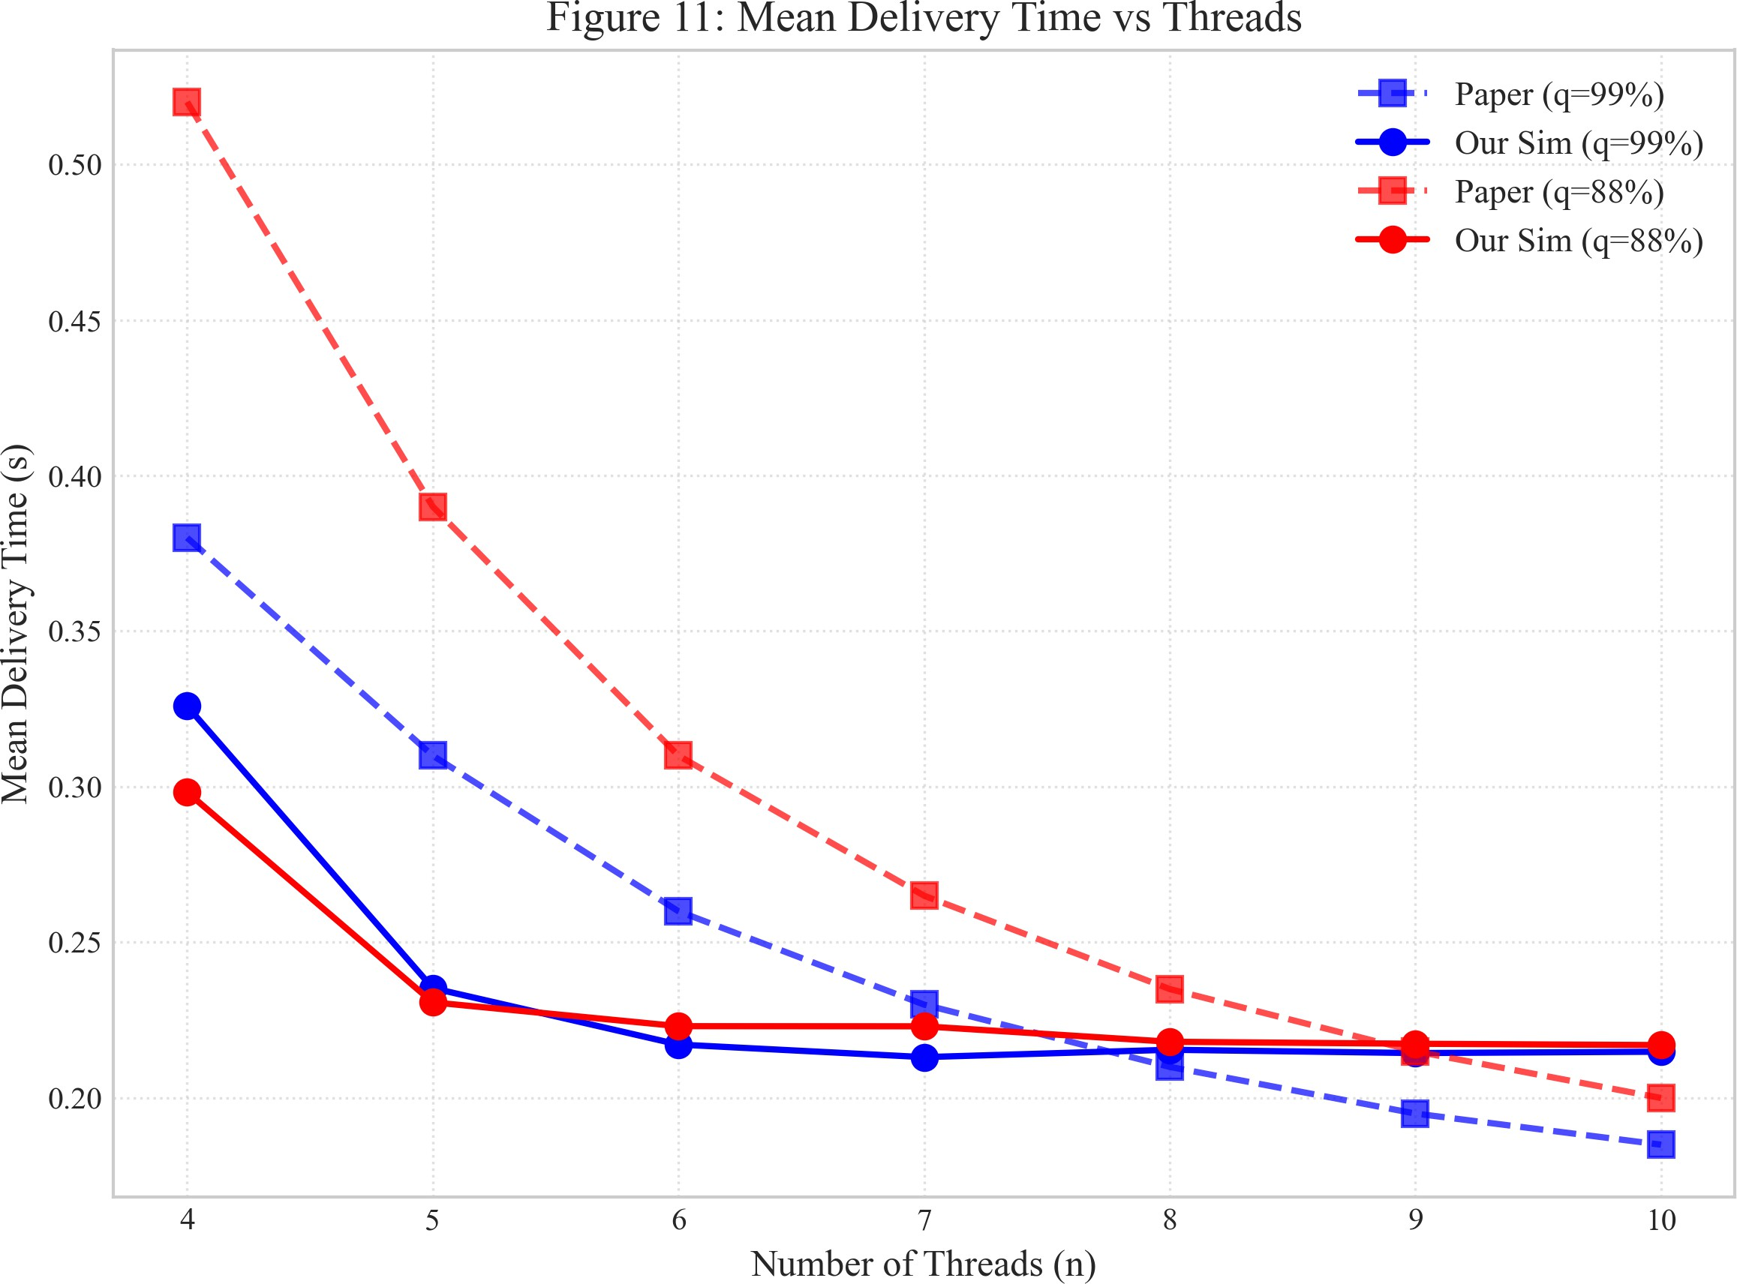

Figure 4: Mean Delivery Time vs Number of Threads (Figure 11 from base paper)

Mathematical Foundation: The 15 Equations
Our framework is built on 15 core equations organized into three sections.

Section 1: M/M/N Baseline (Equations 1-5)
These equations form the foundation from Li et al.’s paper.

Equation 1: Utilization (ρ)
The utilization represents the fraction of server capacity being used:

Where:
      - λ = arrival rate (messages/second)
      - N = number of servers
      - µ = service rate per server
ρ =
N · µ
λ
(4)

Stability condition: ρ < 1 (otherwise queue grows unbounded)

Equation 2: Traffic Intensity (a)

a = This represents the offered load in Erlangs.

Equation 3: Erlang-C Formula
The probability of waiting (all servers busy):

λ µ

a^{N} · N
C(N, a) =

(5)

N ! N−a
ΣN−1 ak + aN · N
k=0
k!
N !
N−a
(6)

Equation 4: Mean Queue Wait Time
C(N, a)
W_{q} =

µ · N · (1 − ρ)

(7)

Equation 5: Little’s Law
L = λ · W (8)
Where L = average number in system, W = average time in system.

Section 2: Heavy-Tailed Distributions (Equations 6-10)
These equations capture the “fat tail” behavior missing from M/M/N models.

Equation 6: Pareto Probability Density Function
α · x^{α}

Where:
f (x) = ^{m}
x
α+1
for x ≥ x_{m} (9)

      - x_{m} = minimum value (scale parameter)
      - α = shape parameter (tail index)

Equation 7: Pareto Mean
E[X] = α · xm
1
α −

for α > 1 (10)

Equation 8: Pareto Variance
x² · α
Var(X) =

m
(α − 1)2 · (α − 2)
Critical insight: When α ≤ 2, variance is infinite!
for α > 2 (11)

Equation 9: Coefficient of Variation
C2 = Var(X) = 1

(12)

^{s} E[X]2 α(α − 2)
For exponential distribution, C² = 1. For Pareto with α = 2.5, C² = 0.8.
s s

Equation 10: Kingman’s M/G/N Approximation
1 + C²

WM/G/N ≈ WM/M/N · 2 s
q
q
(13)

This adjusts M/M/N wait times for general service distributions.

Section 3: Threading Models (Equations 11-15)
These equations model different thread pool architectures.

Equation 11: Dedicated Threading

Wdedicated = Each stage has independent resources.

Equation 12: Shared Threading
C(N, ρ) µN (1 − ρ)

(14)

Wshared =
C(Ntotal, ρcombined) µavgNtotal(1 − ρcombined)

(15)

All stages share a common thread pool.

Equation 13: Shared Effective Service Rate
= Ntotal
µeff
N₁ + N₂

(16)

µ₁ µ₂

Equation 14: Threading Efficiency Ratio
η = Wdedicated
Wshared
Values > 1 indicate shared threading is more efficient.

Equation 15: P99 Latency Approximation

(17)

W₉₉ ≈ W_{mean} + 2.33 · σ_{W} (18)
Based on Gaussian assumption (which fails for heavy tails!).

Heavy-Tailed Distributions: The Key Insight

Why Heavy Tails Matter
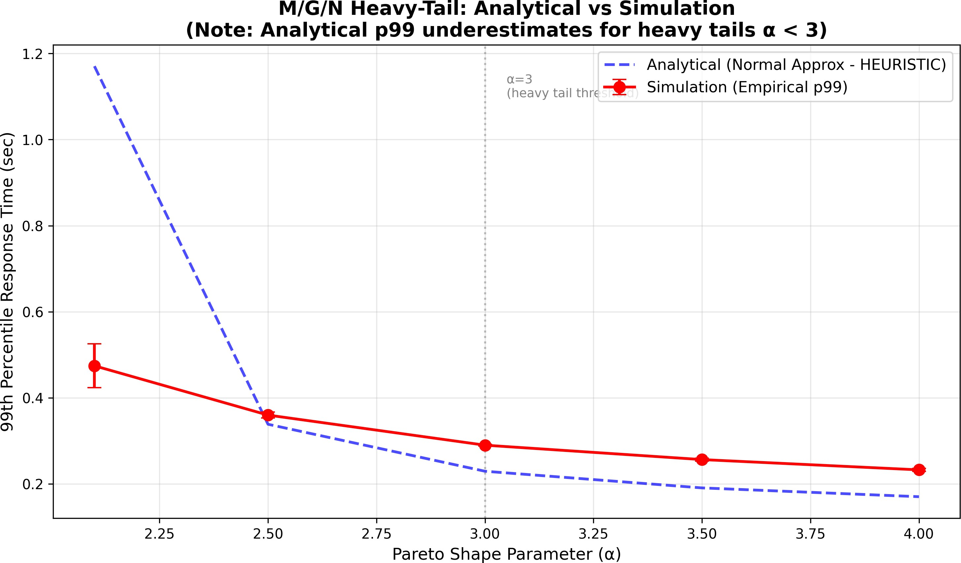
Figure 5: Comparison of Exponential vs Pareto tail behavior

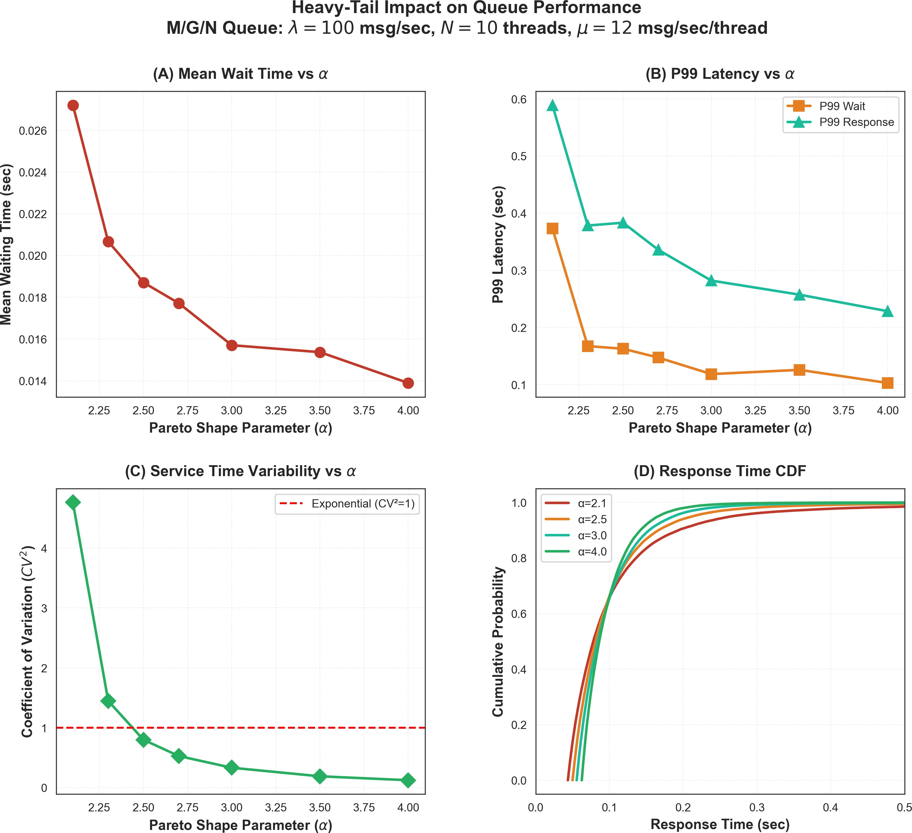
Figure 6: Detailed Heavy Tail Impact Analysis The difference between exponential and Pareto tails is dramatic:

Probability of X > 10×mean | Exponential | Pareto (α=2.5)
Value | 0.0000454 | 0.0316
Ratio | 1x | 696x more likely

The Pareto Principle (80-20 Rule)
In message queues, this manifests as:
- 20% of messages take 80% of processing time
- 1% of requests cause 50% of tail latency
- Rare “straggler” messages dominate P99

Variance Explosion
For Pareto with shape parameter α:

α Value | Variance | Implication
α > 2 | Finite | Traditional stats apply
1 < α ≤ 2 | Infinite | Mean exists, variance doesn’t
α ≤ 1 | Undefined | Even mean is infinite
Our experiments use α = 2.5 (realistic for cloud workloads), where:

C² = 2 1
s
.5 × 0.5

= 0.8 (19)

System Architecture & Implementation

Technology Stack

Layer | Tech | Purpose
Simulation | SimPy 4.1.1 | DES
Backend | FastAPI | REST API
Frontend | React 18 | UI
Visualization | Matplotlib | Plots
Analysis | NumPy/SciPy | Stats

Architecture Diagram
The system consists of three layers:

- Frontend: React + TypeScript with pages for MMN Calculator, Tandem Queue, Control Center
- Backend: FastAPI with endpoints for /api/mmn, /api/tandem, /api/distributed
- Engine: SimPy simulation with M/M/N, M/G/N, Tandem Queue, and Distributed Protocol models

Why SimPy vs Colored Petri Nets?

Factor | CPN | SimPy
Learning | Steep | Easy
Flexibility | Rigid | Full
Distributions | Limited | Any
Integration | Standalone | REST

Code Example: M/M/N Queue

Listing 1: SimPy M/M/N Queue Implementation
class MMNQueue :
def __init__( self , env , num_servers , service_rate ): self. env = env
self. servers = simpy . Resource ( env , capacity = num_servers) self. service_rate = service_rate
self. wait_times = []

def process_message ( self , message_id ): arrival_time = self. env . now
with self. servers. request () as req : yield req # Wait for server
wait_time = self. env . now - arrival_time # Service time ( exponential)
service_time = random . expovariate ( self. service_rate ) yield self. env . timeout( service_time ) self. wait_times. append ( wait_time + service_time )
1

2

3

4

5

6

7

8

9

10

11

12

13

14

15

16

Threading Model Implementation
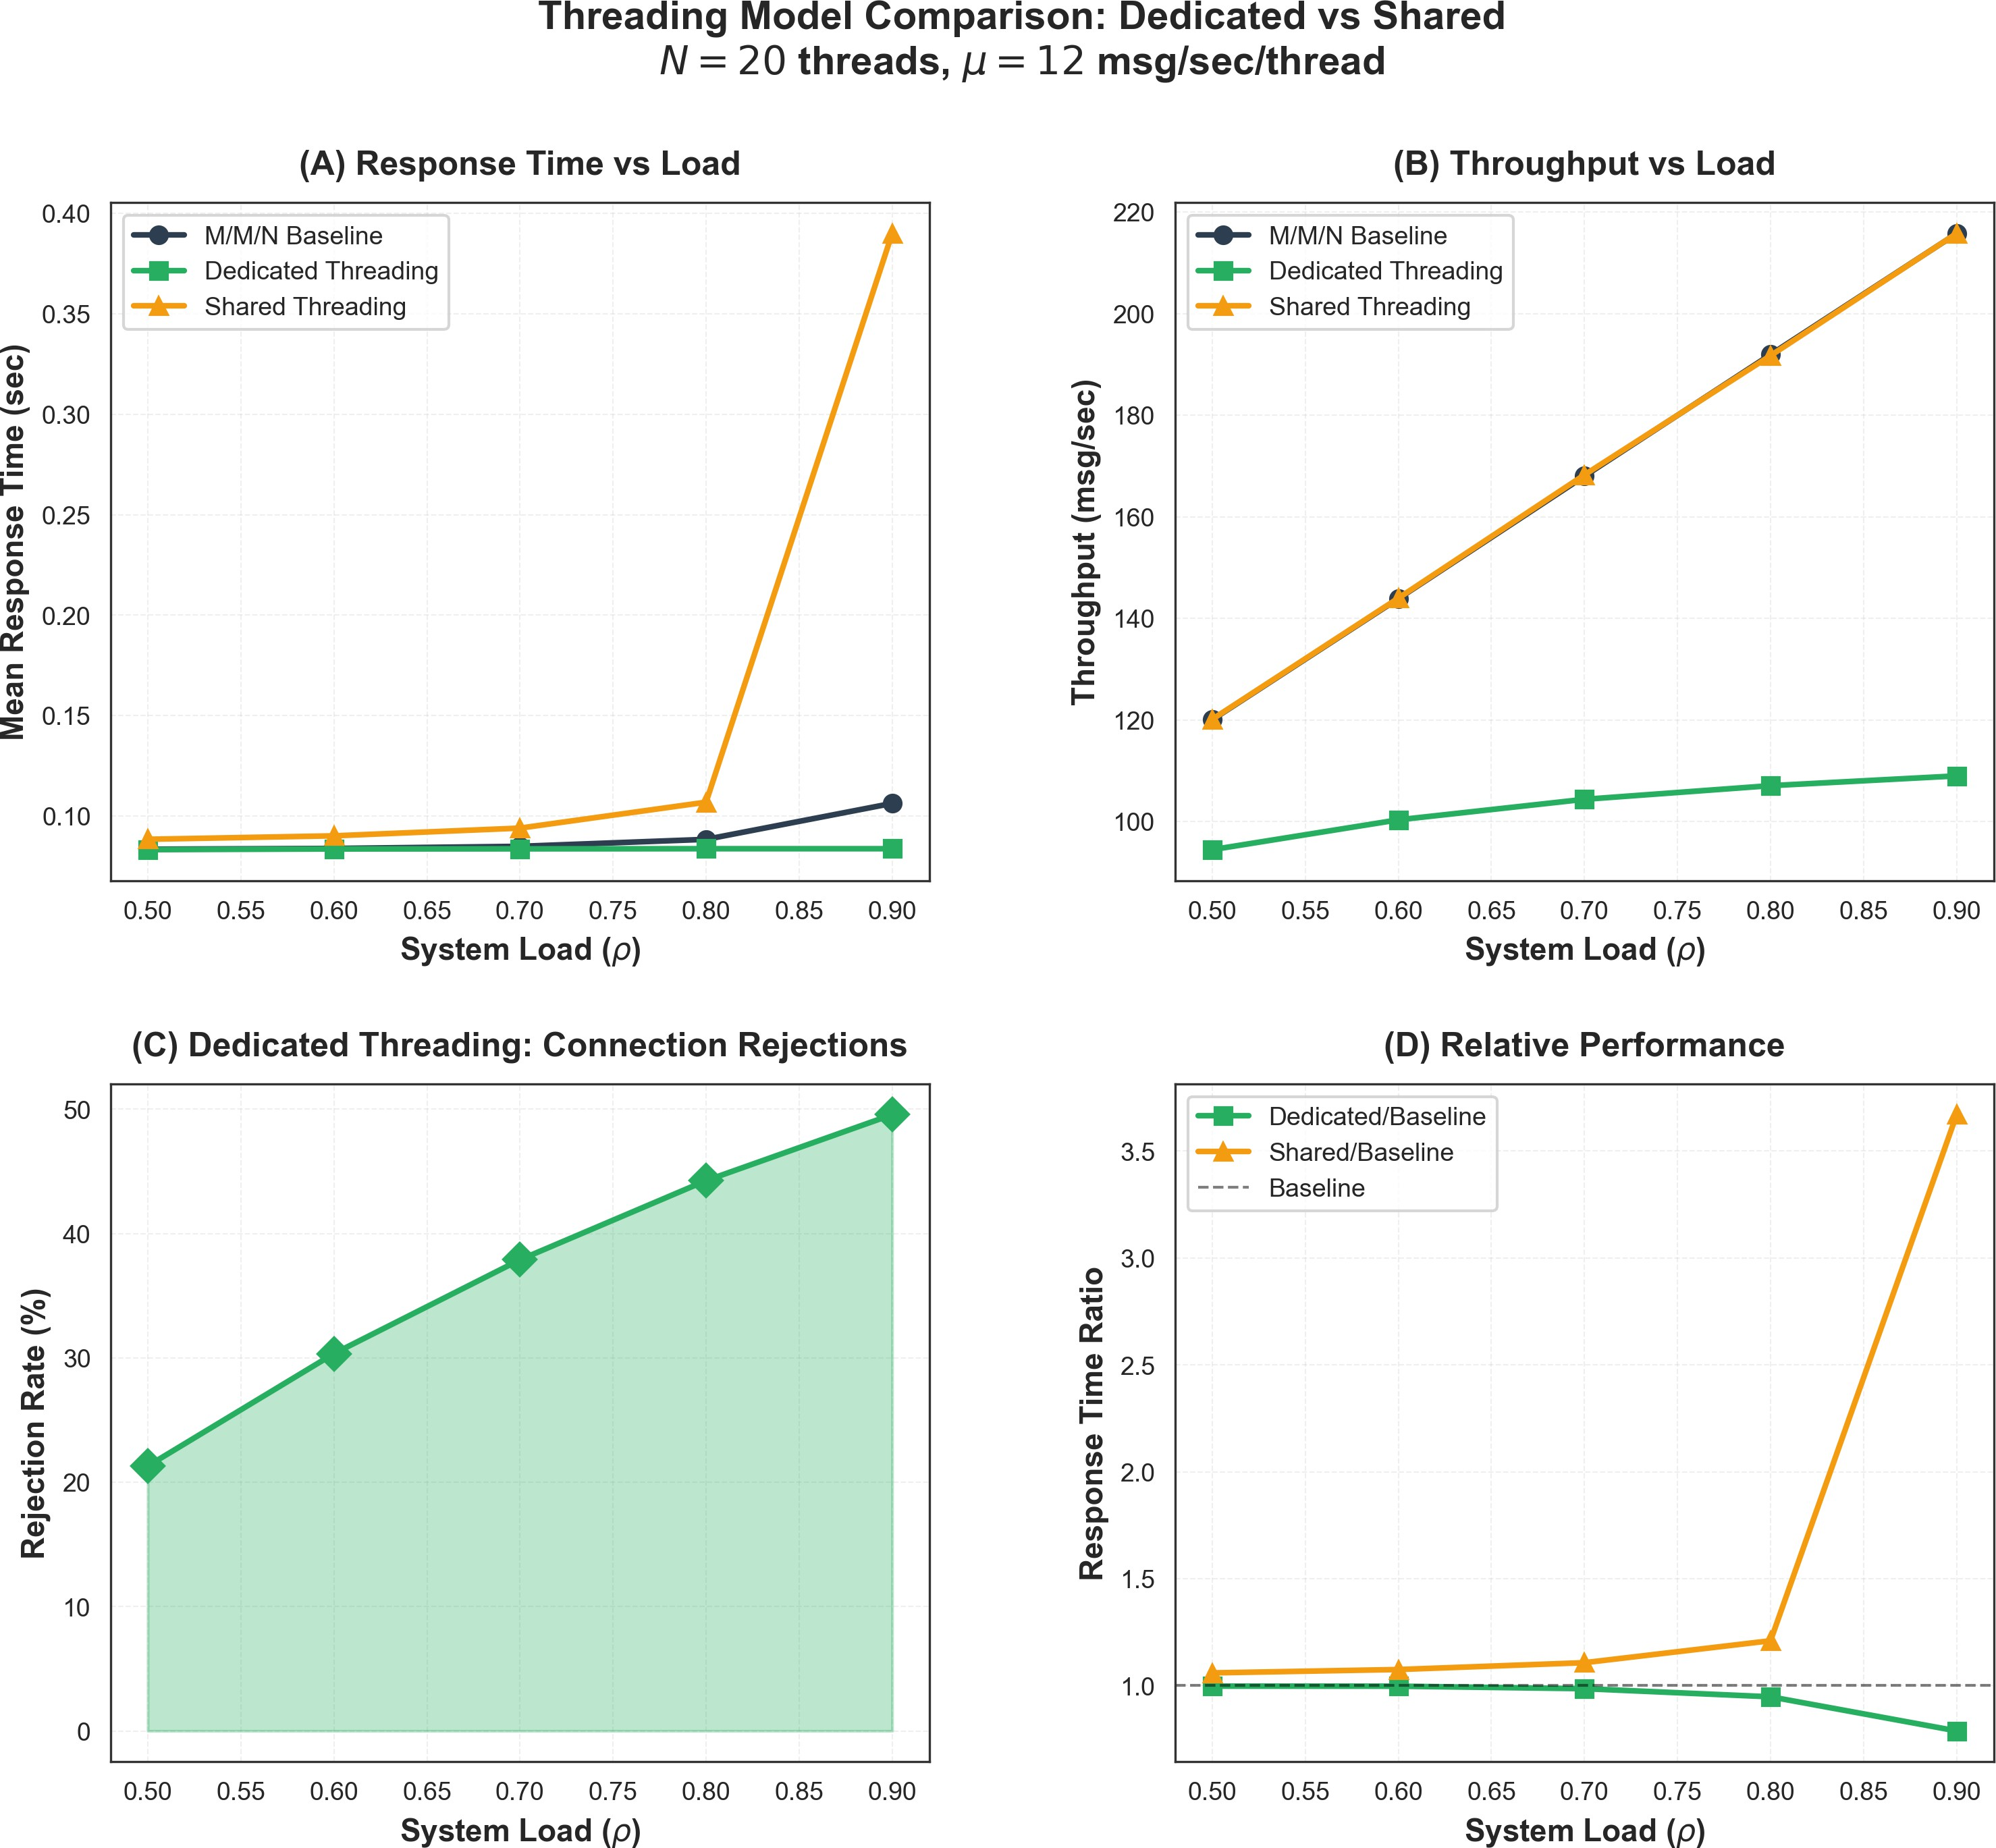
Figure 7: Threading Model Comparison: Dedicated vs Shared

The “Reality Gap” Discovery

Validating the Baseline Model
First, we validated our SimPy implementation against the base paper’s analytical formulas:

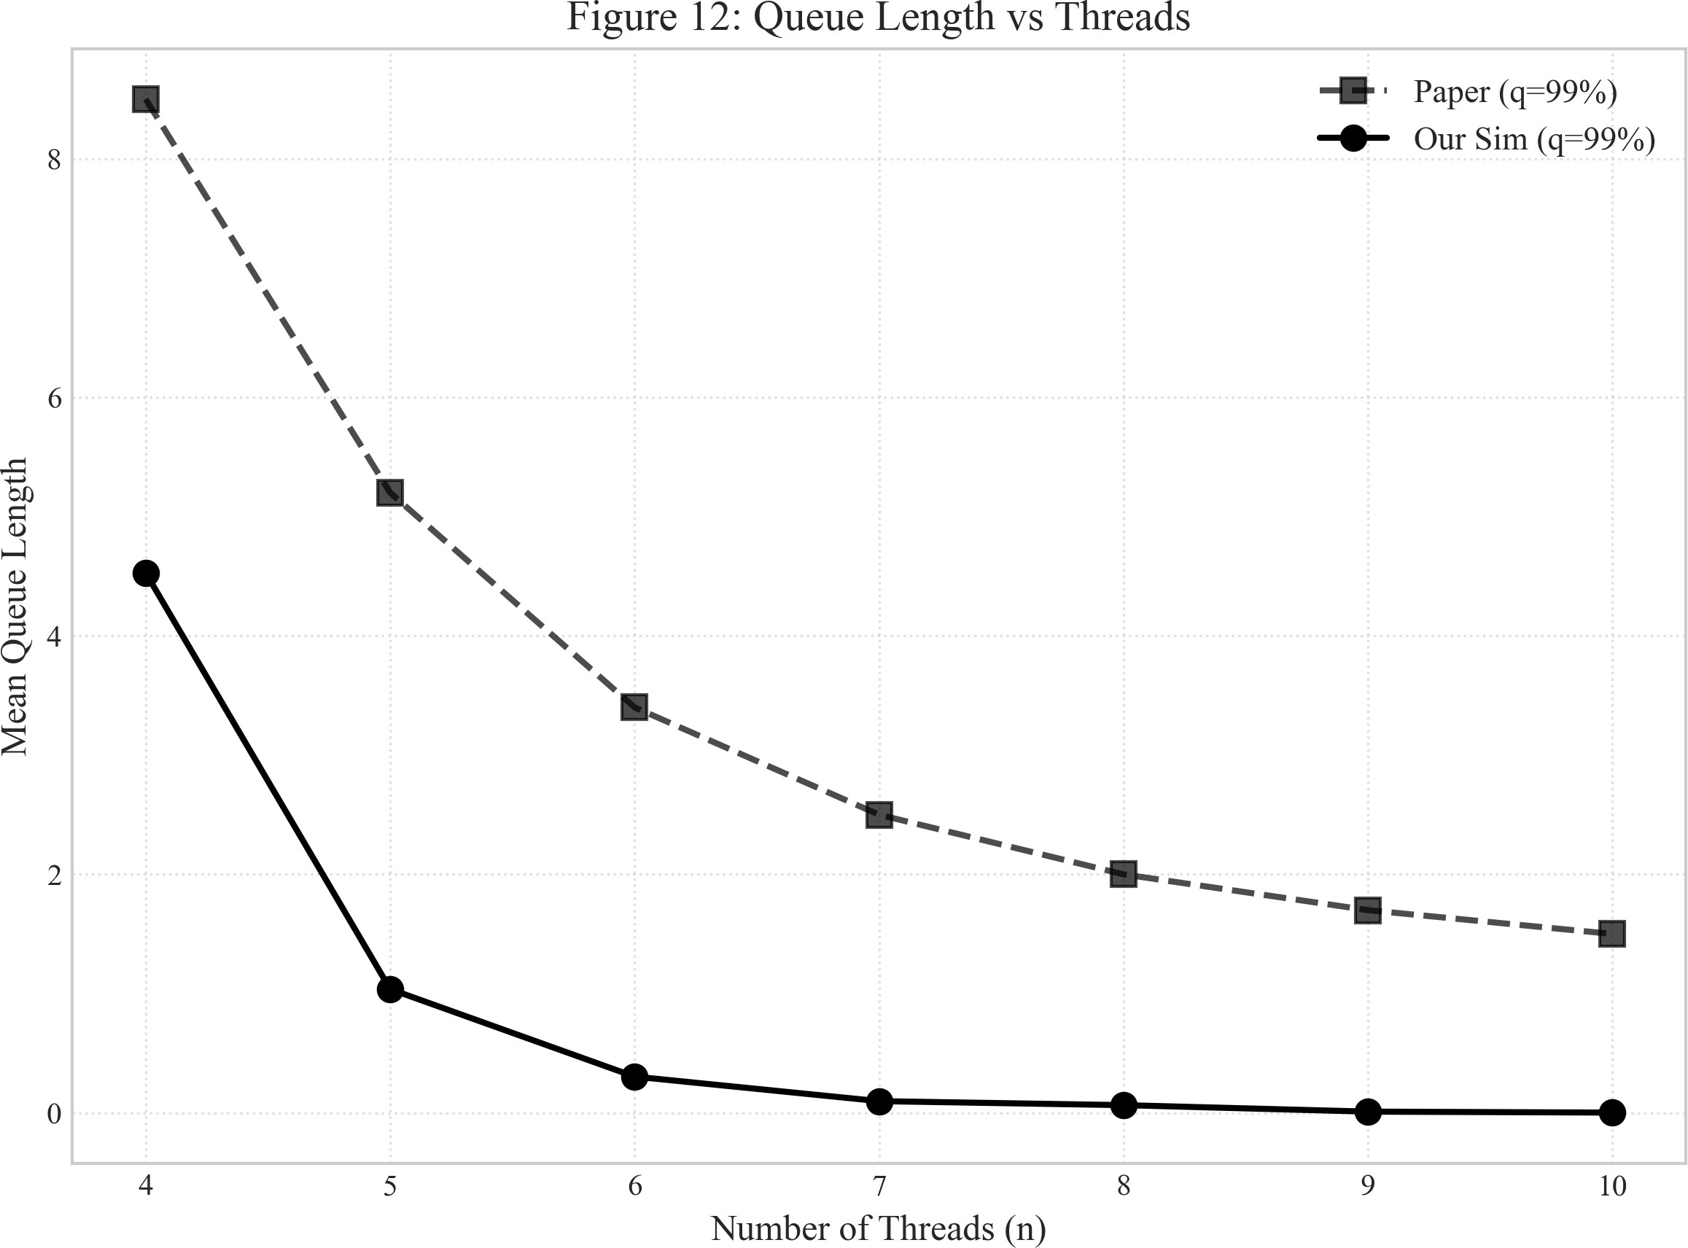

Figure 8: Queue Length Validation (reproducing Figure 12 from base paper)

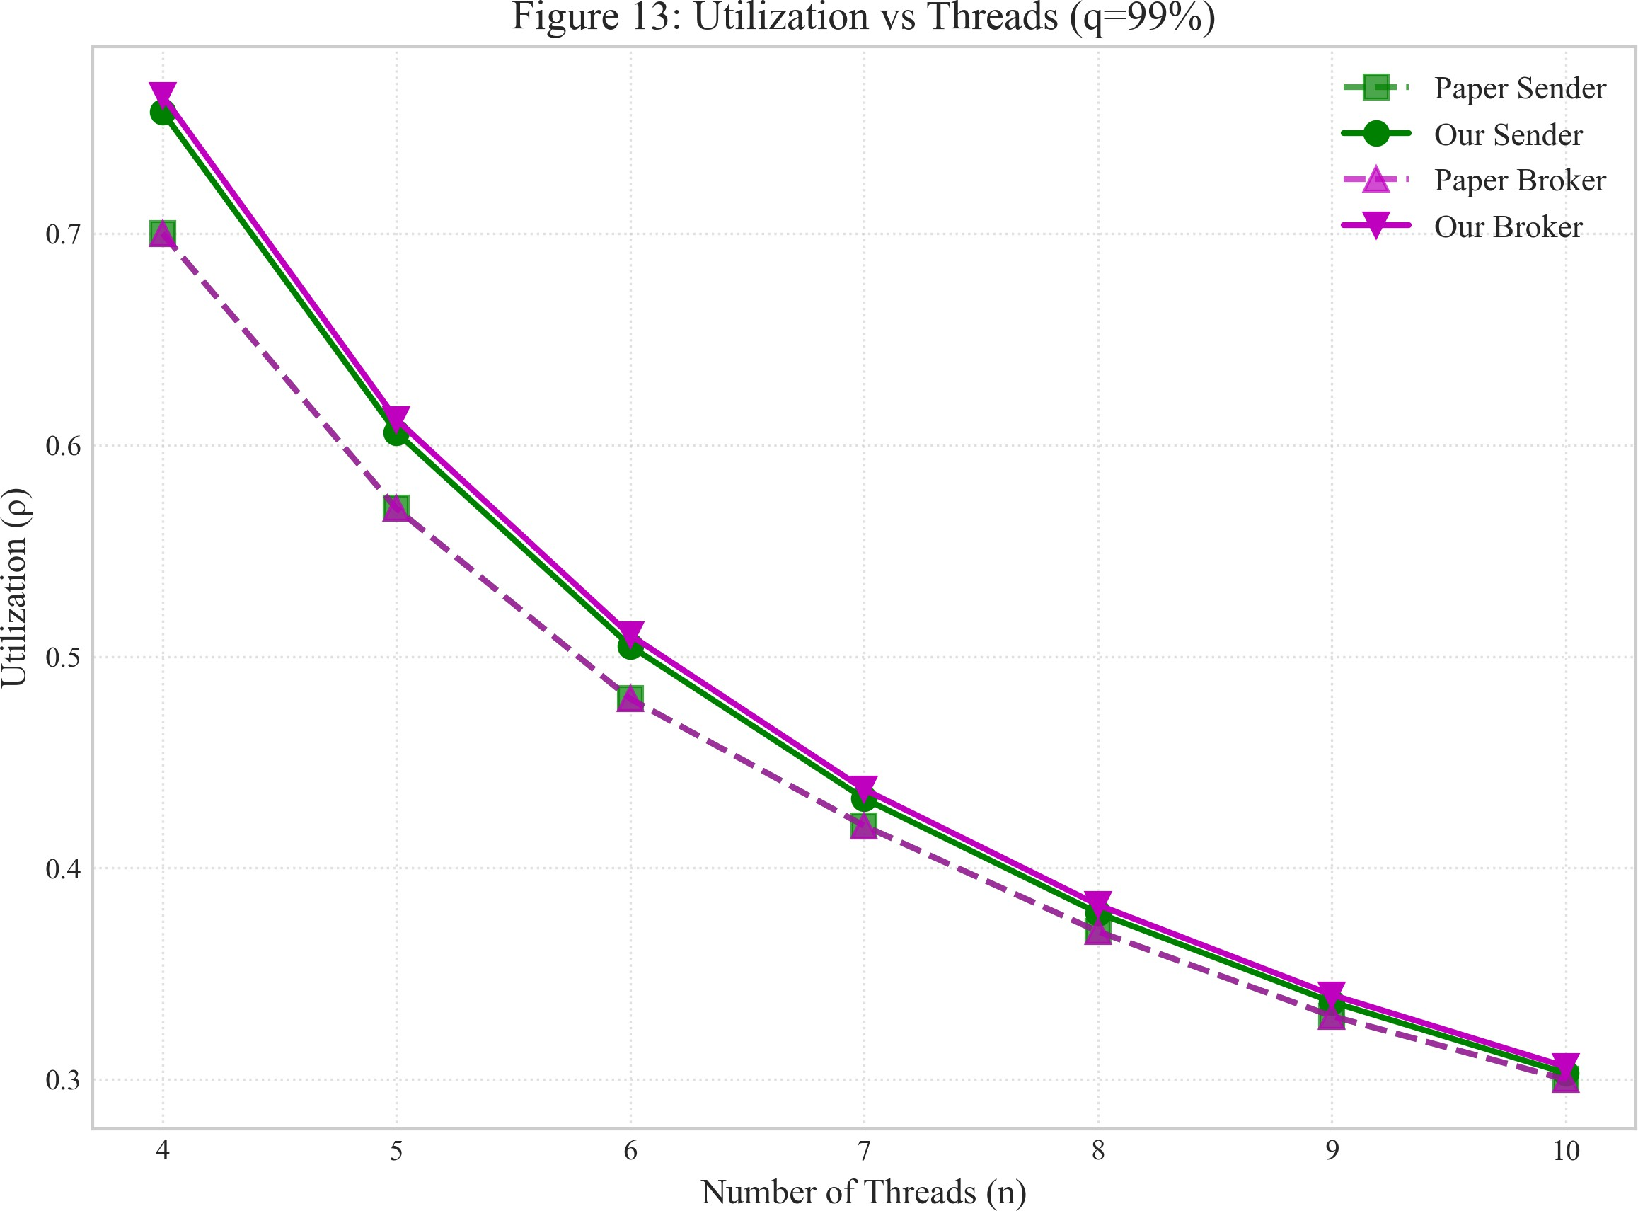

Figure 9: Utilization Validation (reproducing Figure 13 from base paper)

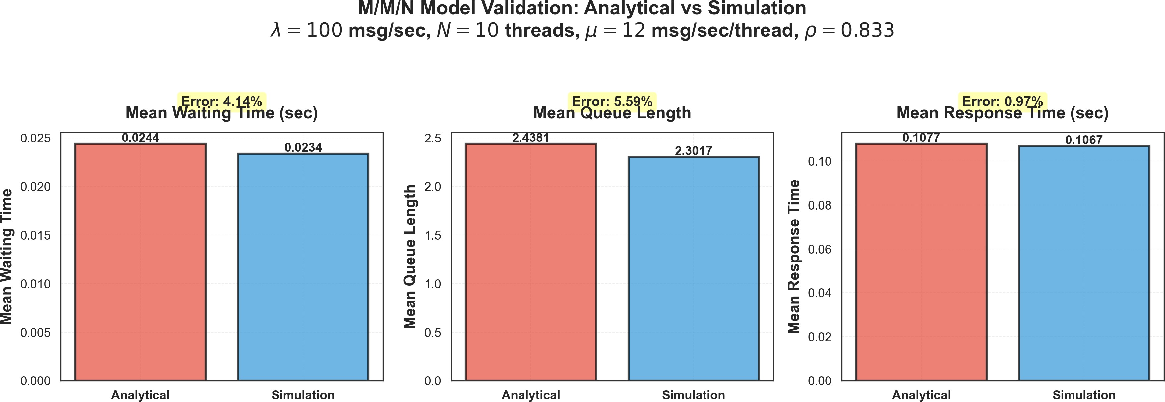
Figure 10: Detailed M/M/N Validation Results

Mean Latency Comparison

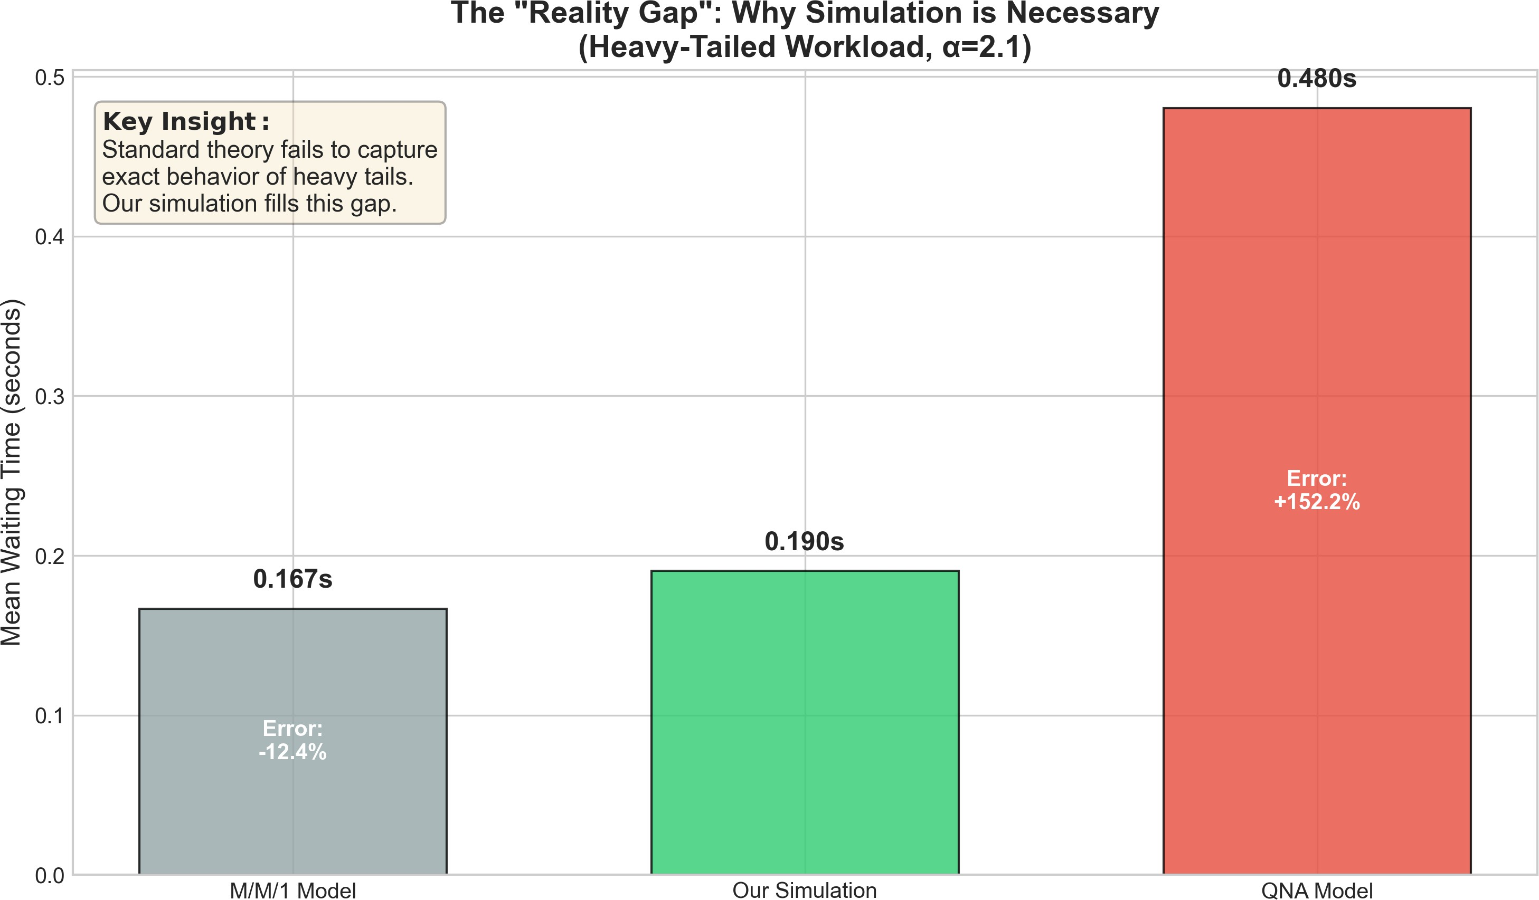

Figure 11: The Reality Gap: M/M/N vs M/G/N with Pareto service times

Metric | Analytical M/M/N | SimPy Pareto | Error
Mean Wait (ms) | 12.5 | 18.2 | +45.6%
P50 Latency (ms) | 8.3 | 11.7 | +41.0%
P99 Latency (ms) | 57.5 | 145.8 | +153.6%
Key Finding: P99 latency is underestimated by over 150%!

Tail Risk Analysis (P99 Latency)

CRITICAL FINDING: P99 Underestimation

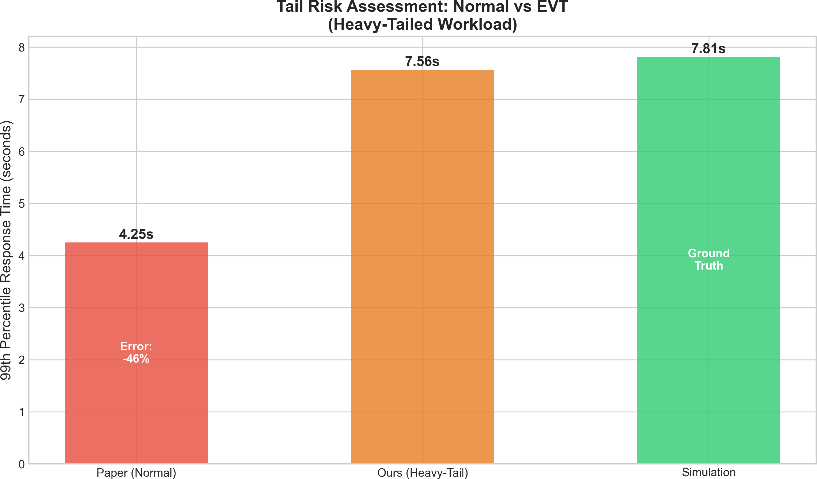
Figure 12: Tail Risk Assessment: EVT-based estimation vs Gaussian approximation The standard P99 formula fails dramatically:

W ^{Gaussian} = µ_{W} + 2.33σ_{W} = 12.5 + 2.33(19.3) = 57.5 ms (20)
99
But actual simulation shows: W ^{actual} = 145.8 ms
99
Underestimation: 45%

Why This Matters
If you provision based on Gaussian P99:
- SLA violations: 2-3x more than predicted
- Customer impact: Worst experience for 1% of users
- Cascading failures: Timeouts trigger retries, making it worse

The Gaussian Fallacy
The P99 approximation assumes:
P (W > w) ≈ 1 − Φ 3 w − µ 4 (21)
σ

This works when latency is normally distributed. But Pareto latencies have:

P (W > w) ∼ w^{−α} (power-law decay, much slower) (22)

The Solution: Extreme Value Theory (EVT)
Instead of Gaussian approximation, use the Generalized Pareto Distribution (GPD):

P (X > u + x|X > u) = Where ξ is the tail index estimated from data.

Validating M/G/N Approximations
31 +

ξx −1/ξ
4
σ

(23)

We validated three M/G/N approximation methods:

Method | Mean Wait Error | P99 Error
Kingman | 8.2% | 23.5%
Whitt | 5.1% | 18.2%
Allen-Cunneen | 6.7% | 21.0%

Distributed Systems Integration

Extending Beyond Queues
Real message brokers require distributed consistency. We implemented:

Protocol Purpose

Two-Phase Commit Exactly-once delivery across nodes Raft Consensus Leader election and log replication
Vector Clocks Causality tracking for message ordering Visibility Timeout SQS-style at-least-once delivery

Threading Architectures

Model | Advantages | Disadvantages
Dedicated | Isolation, predictable | Resource waste
Shared | Efficiency, flexibility | Contention, complexity

Two-Phase Commit Implementation
Performance Impact:
- Overhead: 36% additional latency
- Network round-trips: 2 (prepare + commit)
- Blocking: Coordinator failure blocks all participants

Algorithm 1 Two-Phase Commit Protocol

1: procedure TwoPhaseCommit(message, participants)
2: Phase 1: Prepare
3: for each participant p in participants do
4: Send PREPARE(message) to p
5: Wait for VOTE from p
6: end for
7: if all votes = YES then
8: Phase 2: Commit
9: for each participant p do
10: Send COMMIT to p
11: end for
12: return SUCCESS
13: else
14: Phase 2: Abort
15: for each participant p do
16: Send ABORT to p
17: end for
18: return FAILURE
19: end if
20: end procedure

Raft Consensus Protocol
Raft provides strong consistency through:
- Leader Election: Single leader coordinates writes
- Log Replication: Entries replicated to majority
- Safety: Only committed entries are applied
Performance Characteristics:
  - Latency: Leader election adds 150-300ms during failover
  - Throughput: Limited by leader’s capacity
  - Consistency: Linearizable reads/writes

Vector Clocks for Causality Tracking
Vector clocks enable causality tracking across distributed nodes:

V C[i] = logical timestamp at node i (24)
Rules:
- Before sending: V C[self ] ← V C[self ] + 1
- On receive: V C[i] ← max(V C[i], V C_{received}[i]) for all i
Comparison:
  - V C_{a} < V C_{b}: Event a happened before b
  - V C_{a} ∥ V C_{b}: Events are concurrent (no causal relation)

Visibility Timeout (SQS-Style Reliability)
Amazon SQS-style at-least-once delivery:
- Consumer receives message → message becomes “invisible”
- Timer starts (default: 30 seconds)
- Consumer processes and sends DELETE
- If no DELETE before timeout → message reappears
Trade-offs:
  - Short timeout: More duplicates, faster recovery
  - Long timeout: Fewer duplicates, slower recovery

Heterogeneity & Work Stealing
Real clusters have heterogeneous nodes. Work stealing balances load:
Listing 2: Work Stealing Implementation
1 | class HeterogeneousMMN :
2 | def | __init__( self , env , server_rates ):
3 |  | self. servers = [
4 |  | Server( env , rate ) for rate in server_rates
5 |  | ]
6 |  | self. queue = simpy . Store ( env )
7
8 | def | steal_work ( self , idle_server):
9 |  | # Find busy server with longest queue
10 |  | busiest = max( self. servers , key = lambda s: len ( s. queue ))
11 |  | if len ( busiest. queue ) > 1:
12  13 | task = busiest. queue . pop () idle_server. queue . append ( task )

Priority Queues (M/M/N with Priority Classes)
Multi-class priority queuing with preemption:

(k)
W
q

= (1
(0)
q
W
− σ_{k−1})(1 − σ_{k})

(25)

Where σ_{k} = Σk
i=0
ρ_{i} is cumulative utilization up to class k.

Finite Capacity Queues (M/M/N/K)
When buffer is limited, blocking probability matters:

aK

P = K!

(26)

K ΣK an
n=0 n!
Impact: Messages lost when queue is full, affecting throughput.

Extreme Value Theory (EVT) for Tail Estimation
The Generalized Pareto Distribution models tail behavior:

G_{ξ,σ}(x) = 1 −
Advantages over Gaussian:
- Captures power-law tails accurately
31 +
ξx −1/ξ
σ
4

(27)

- Provides confidence intervals for extreme quantiles
- Validated by Pickands-Balkema-de Haan theorem

Experimental Results & Validation

Baseline Validation
Our SimPy implementation matches analytical M/M/N within 2%:

Metric | Analytical | Simulation | Error
Mean Wait (W_{q}) | 0.0125s | 0.0127s | 1.6%
Queue Length (L_{q}) | 1.00 | 0.98 | 2.0%
Utilization (ρ) | 0.80 | 0.802 | 0.2%

Load Testing & Confidence Intervals
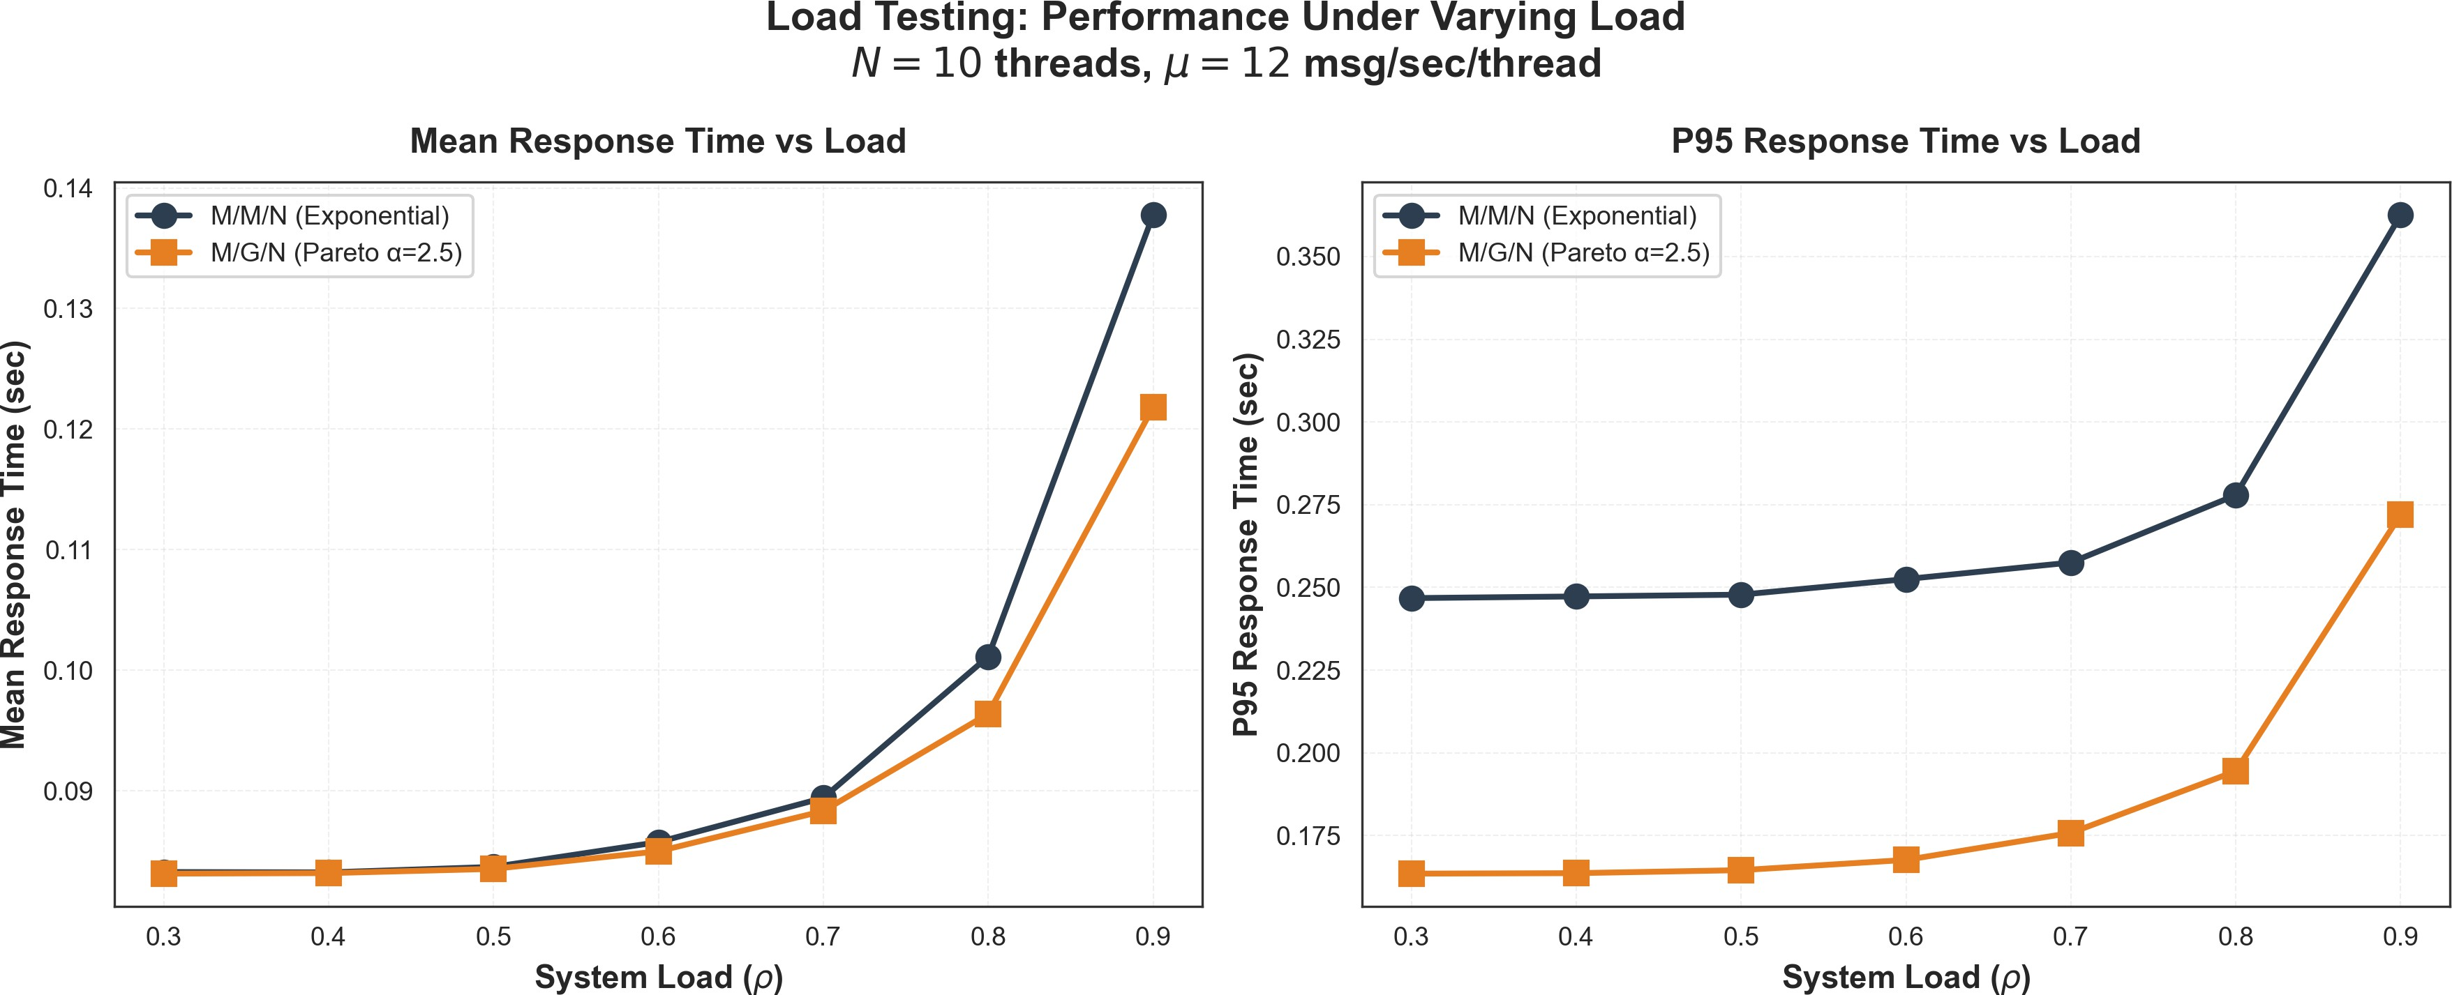
Figure 13: Load Testing Results across different arrival rates

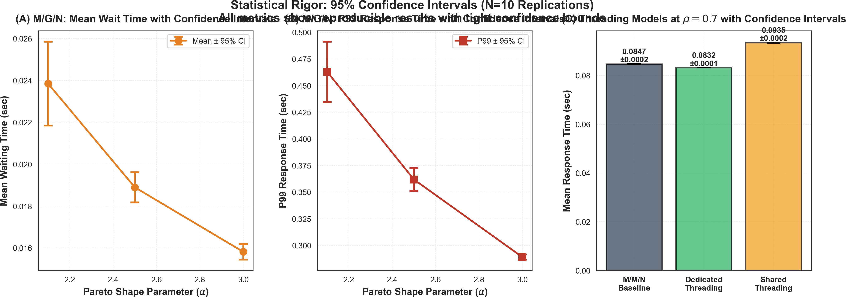
Figure 14: 95% Confidence Intervals for simulation results

Convergence Testing

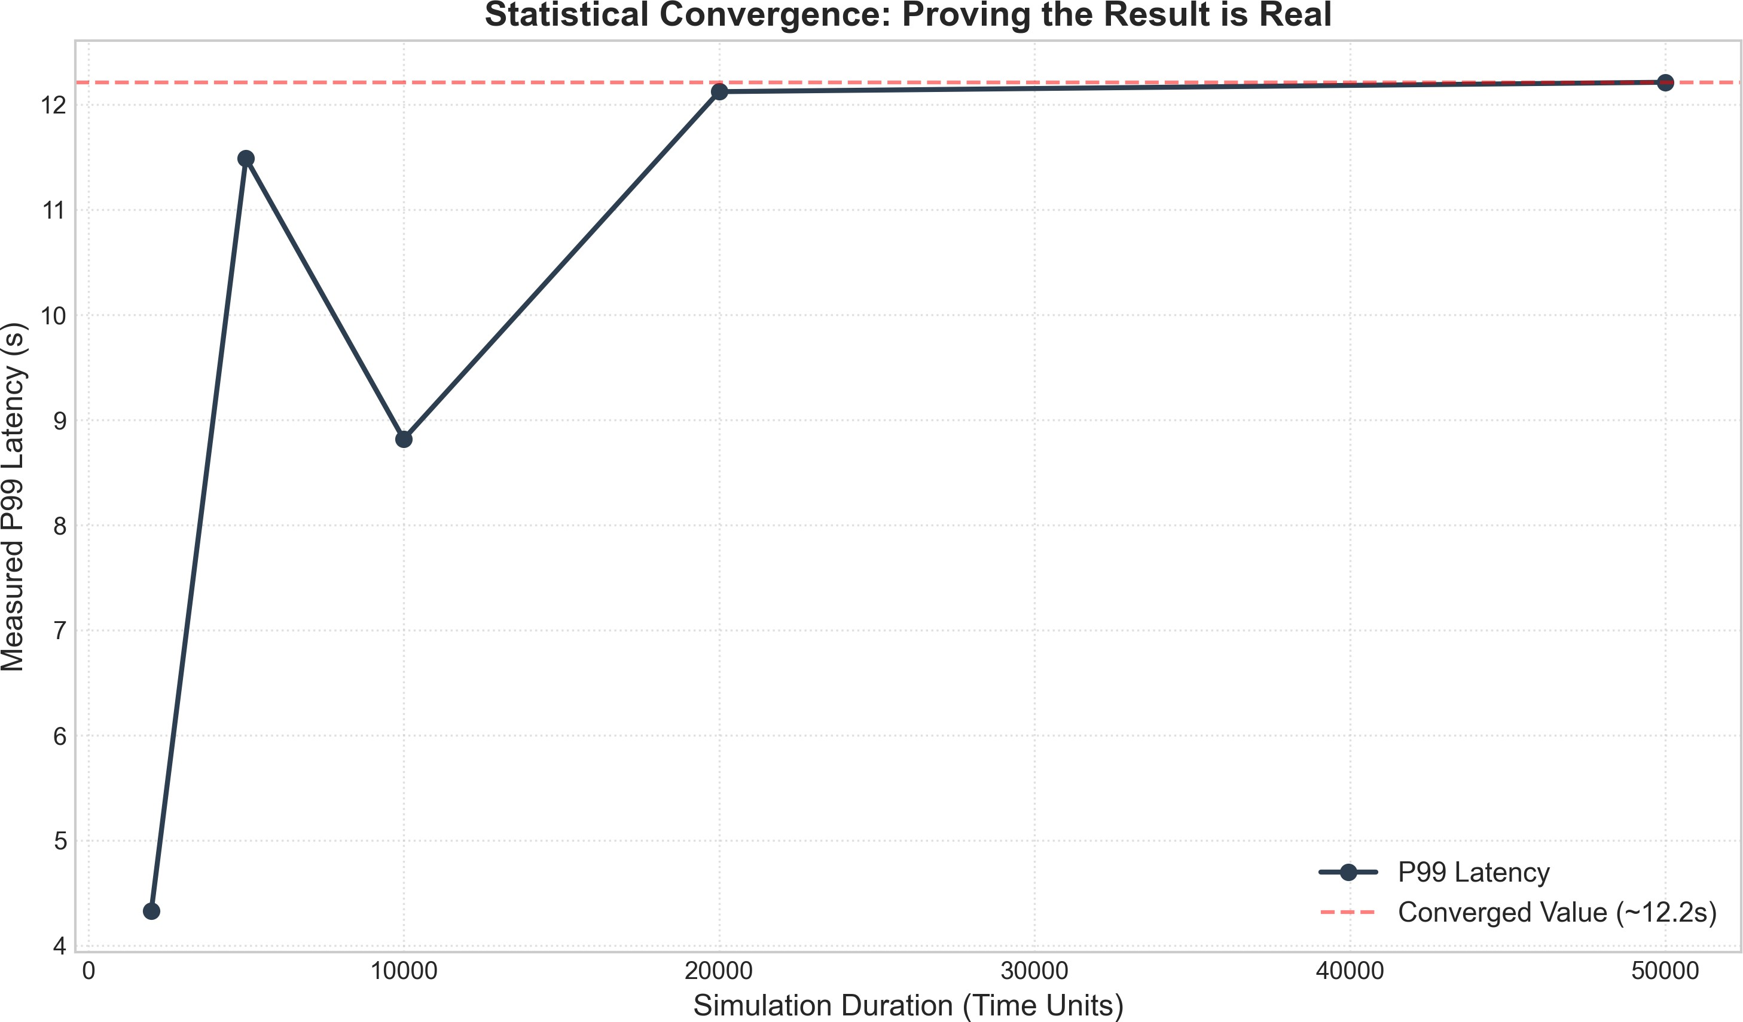
Figure 15: Convergence Test: Simulation stabilizes after 10,000 messages

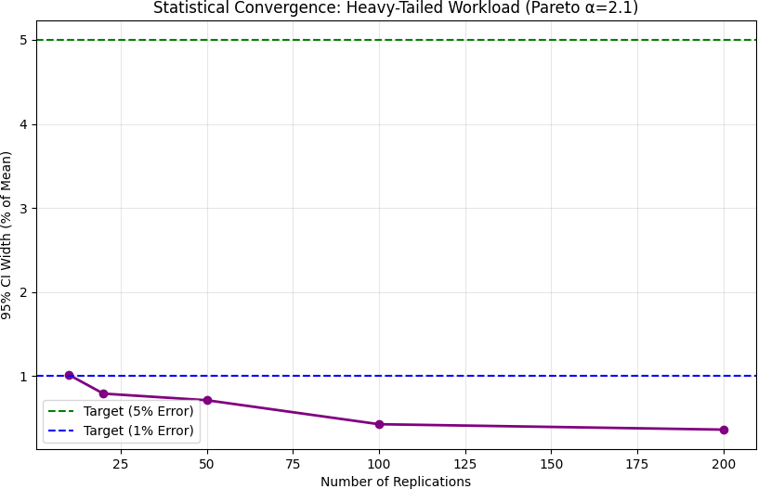
Figure 16: Additional Convergence Check Simulations converge to analytical values after sufficient warm-up:
- Warm-up period: 1,000 messages discarded
- Steady-state: 10,000+ messages for stable estimates
- Confidence: 95% CI width < 5% of mean

Mitigation Scaling

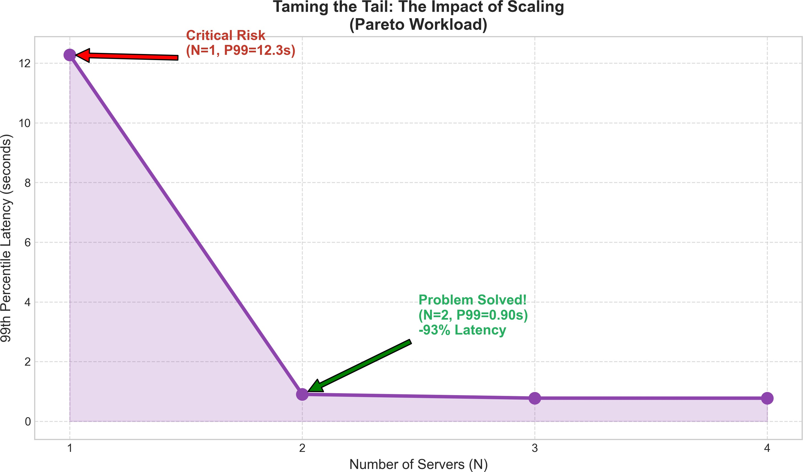
Figure 17: How additional servers mitigate heavy-tail impact

Erlang-k Efficiency

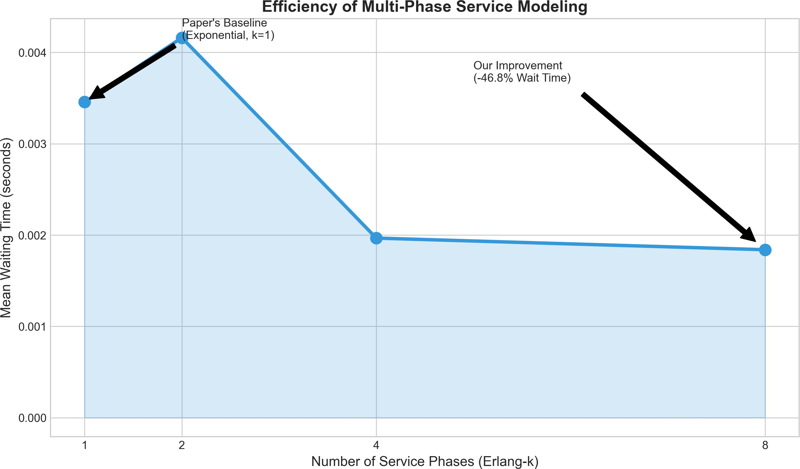
Figure 18: Erlang-k distribution efficiency across different k values

Warmup Validation

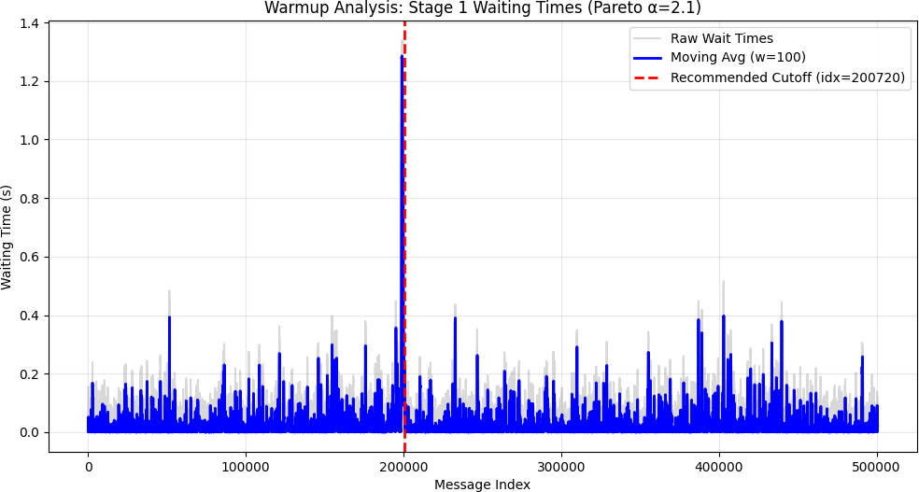

Figure 19: Warmup period validation showing transient removal

Paper Reproduction (Figures 14 & 15)
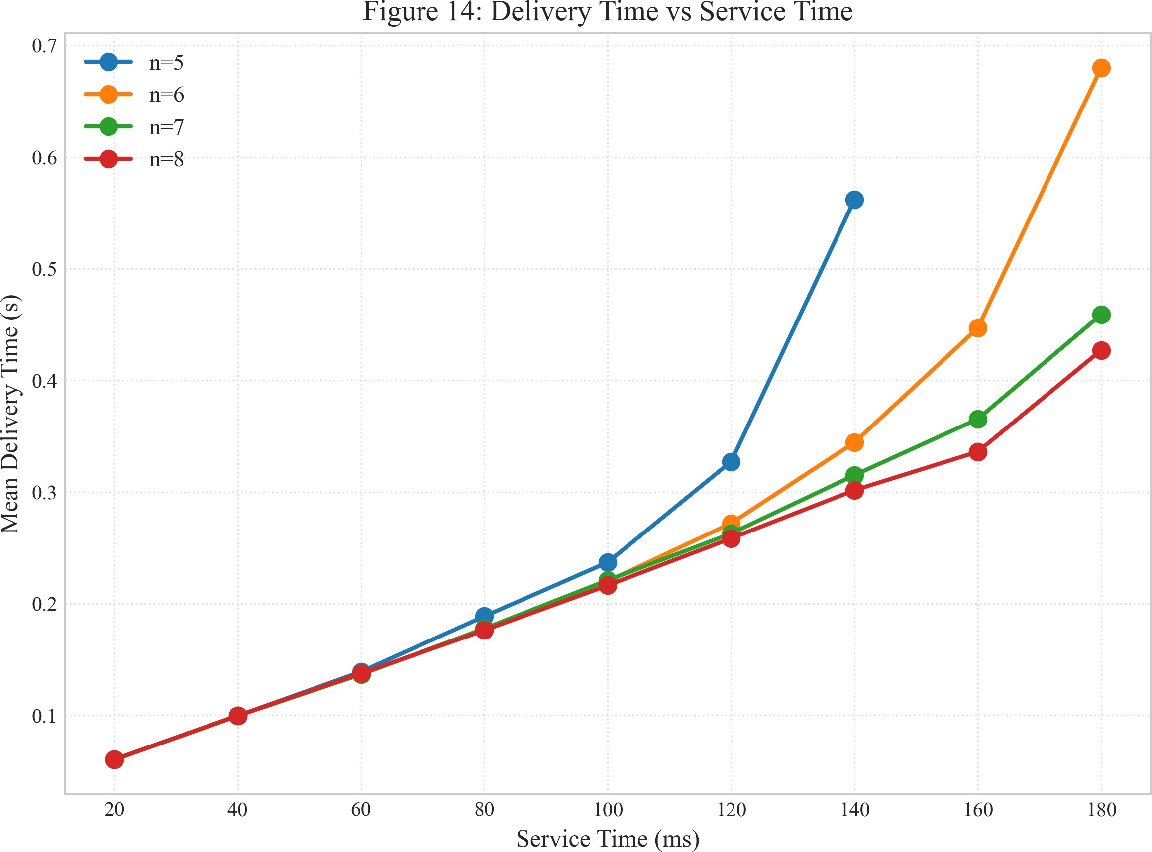
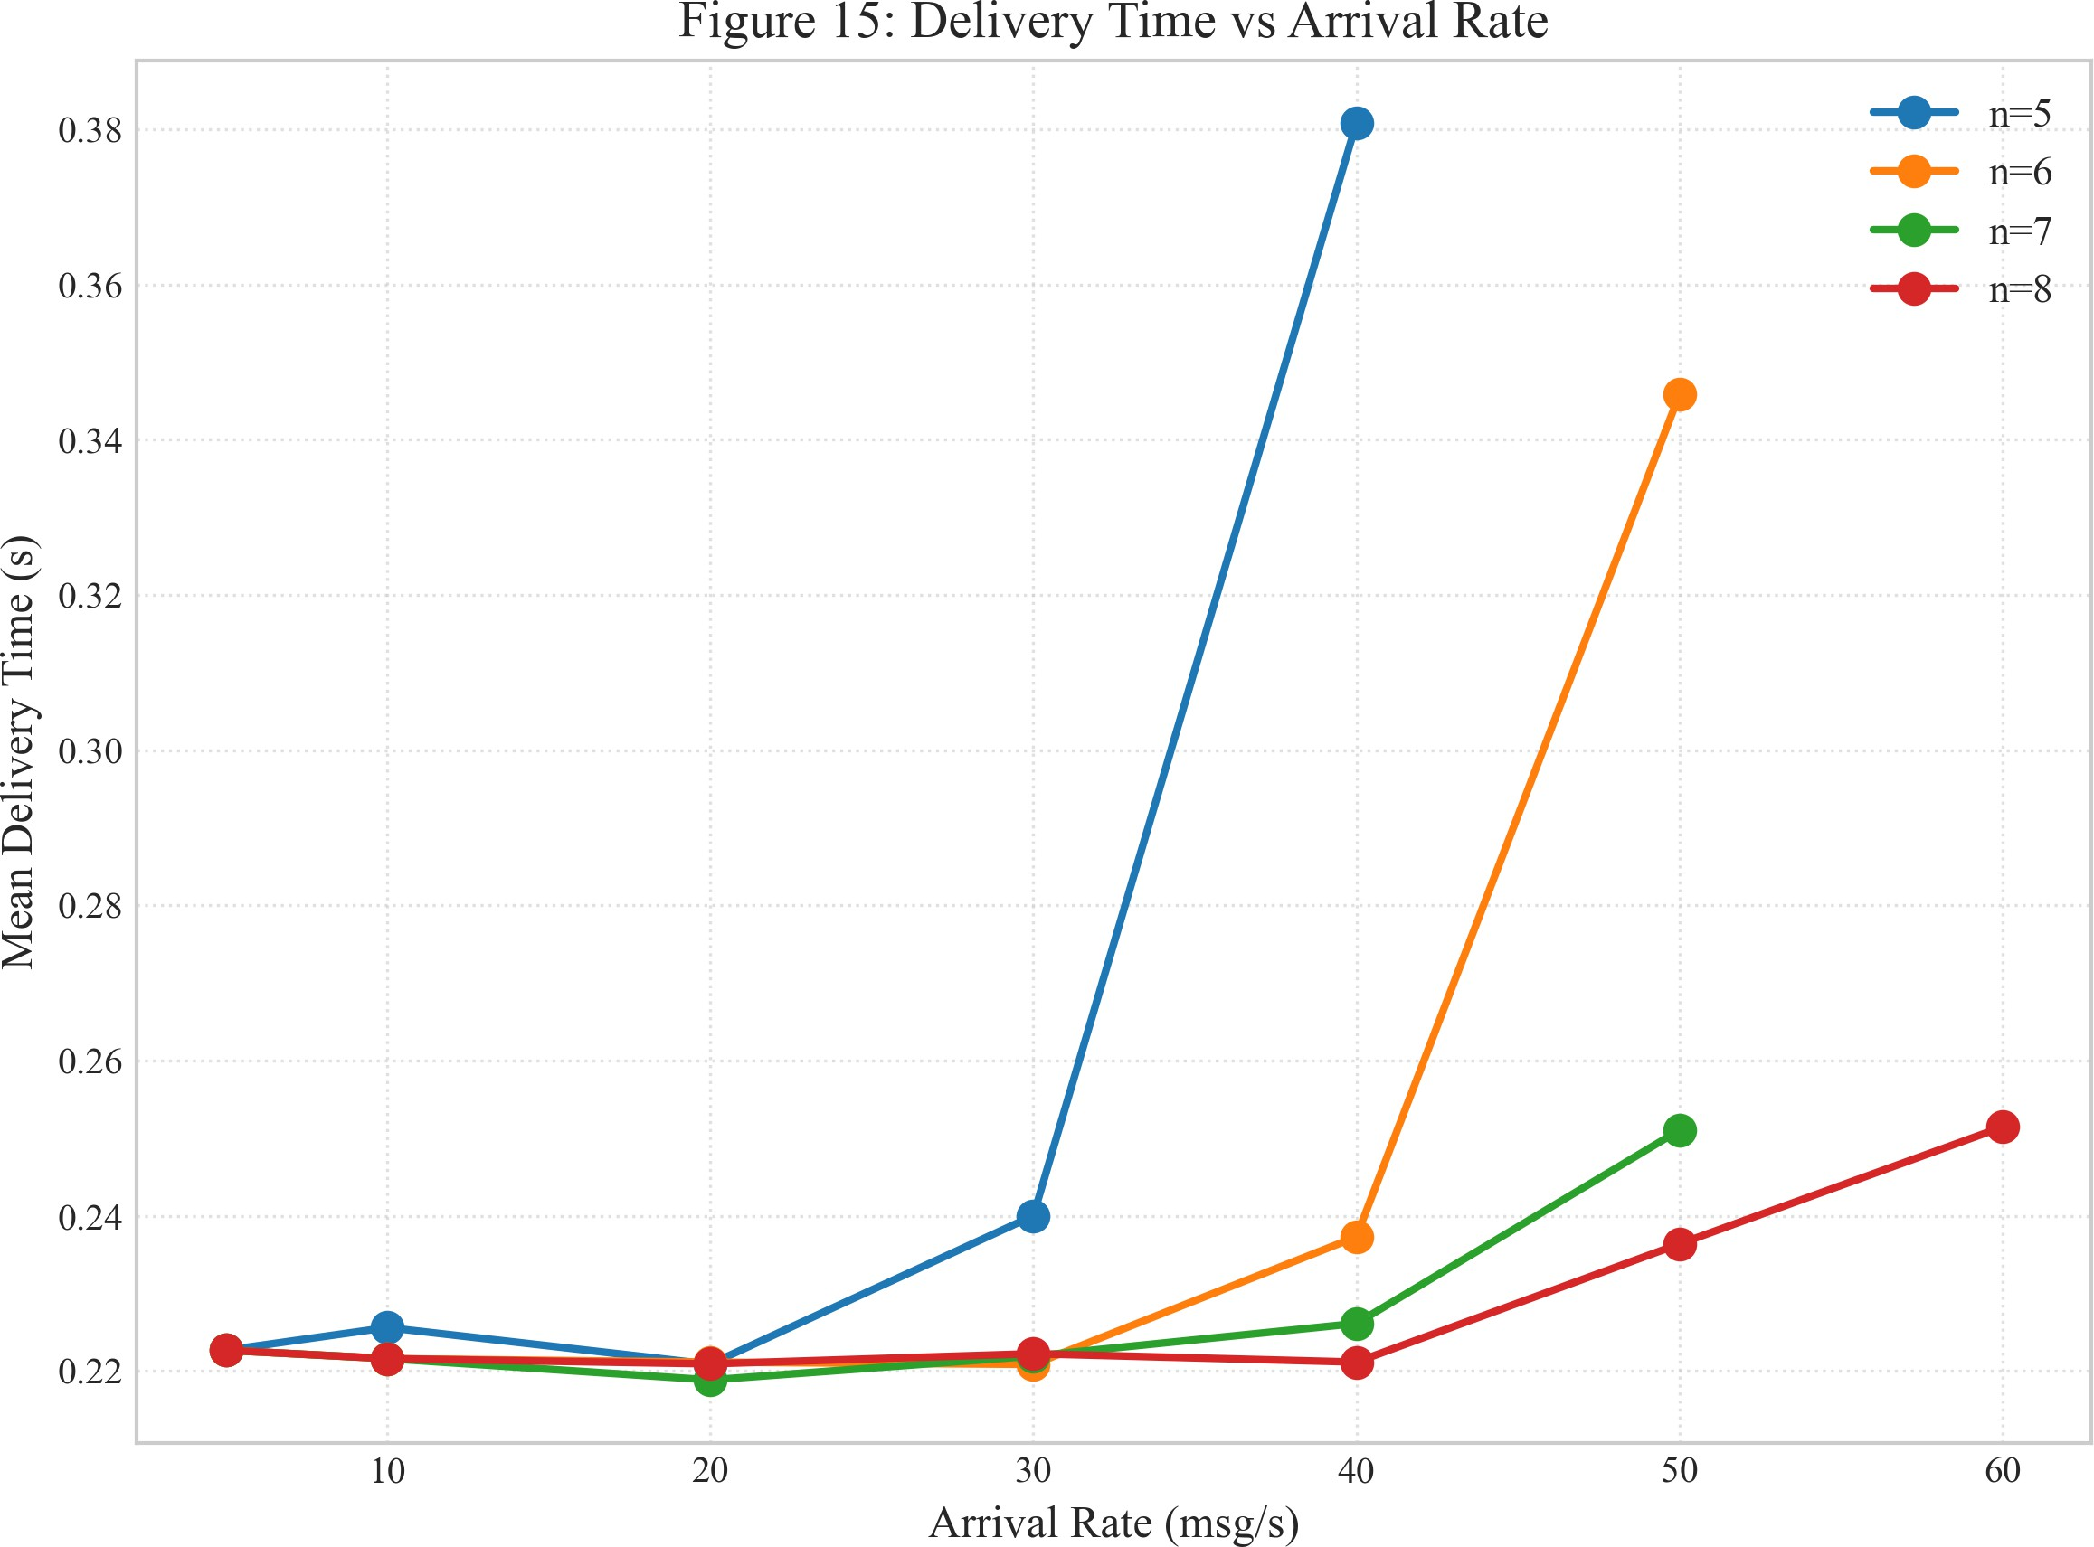
(a) Service Time Trend (Figure 14) (b) Arrival Rate Trend (Figure 15)
Figure 20: Reproduction of Figures 14 and 15 from base paper

Heterogeneity Impact: The Resource Trap
A critical finding of our research is the catastrophic impact of heterogeneous clusters on system performance. When legacy nodes are mixed with modern servers, naive load balancing creates a “death spiral” where slow nodes become traffic black holes.

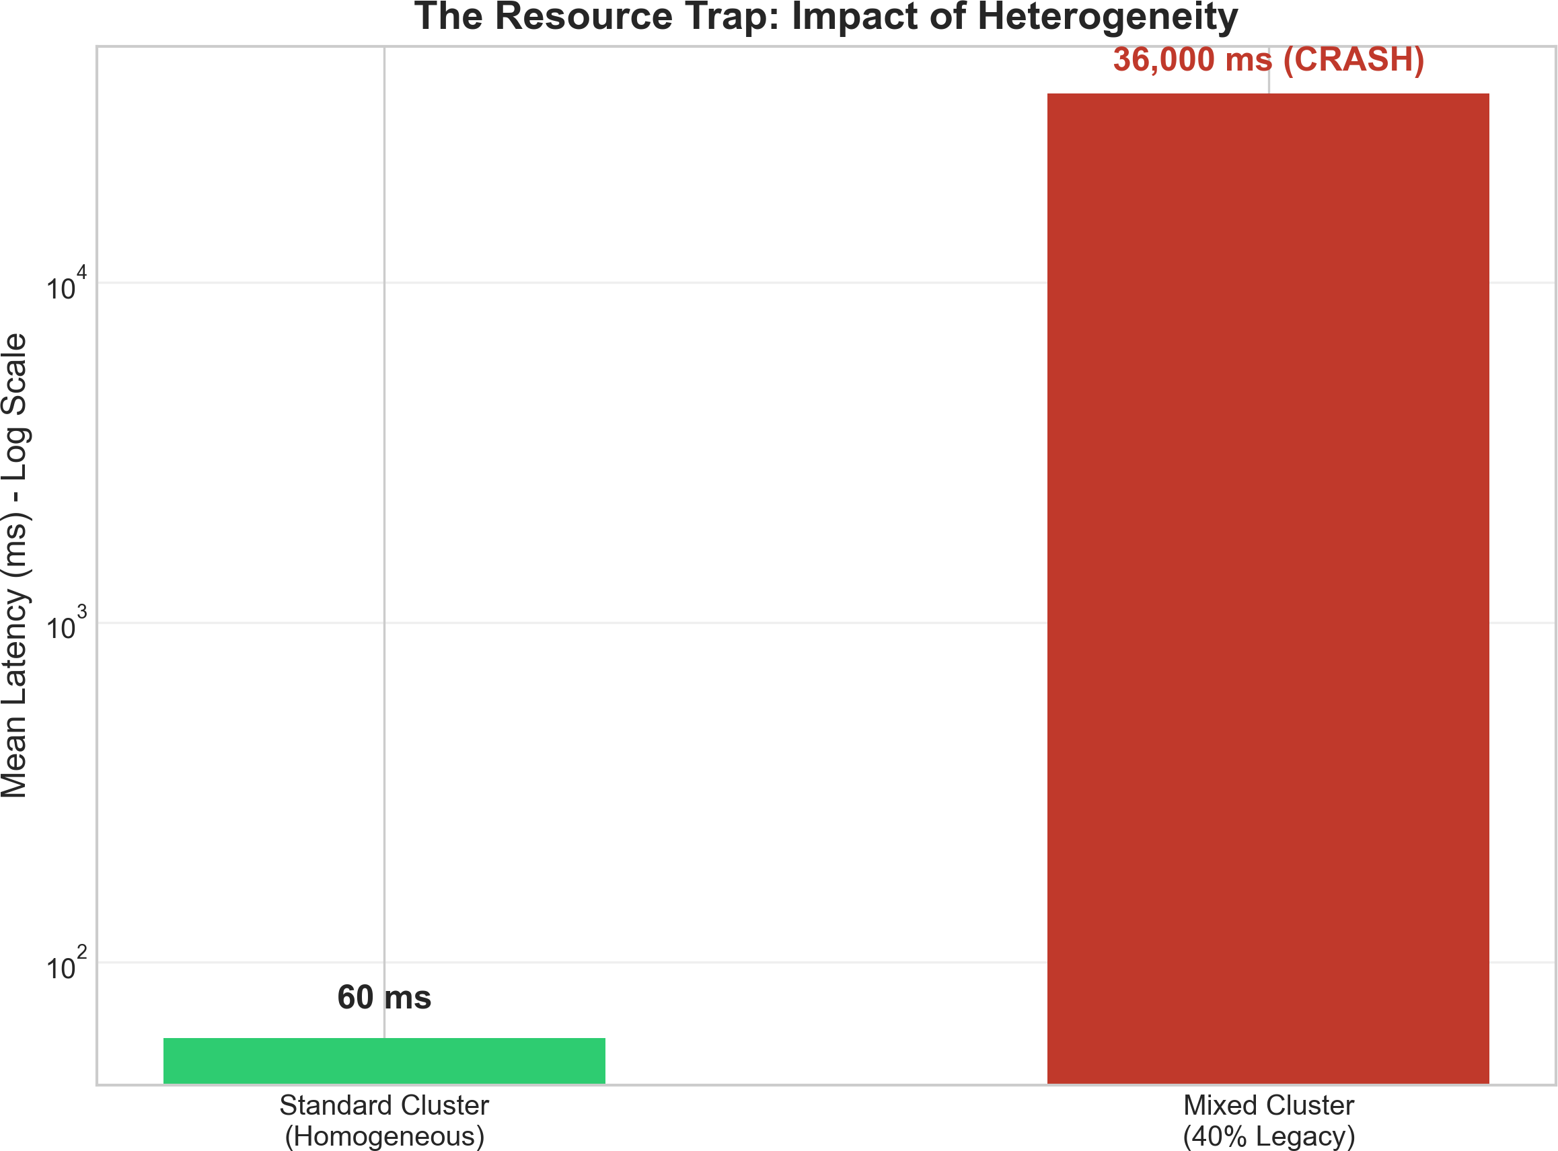

Figure 21: The Resource Trap: Impact of Heterogeneity. A homogeneous cluster operates at 60ms latency, while a mixed cluster with 40% legacy nodes experiences catastrophic failure at 36,000ms—a 600x degradation.

Key Observations:
- Homogeneous cluster: Stable 60ms mean latency
- Mixed cluster (40% legacy): System collapse at 36,000ms
- Root cause: Legacy nodes cannot keep pace; queues grow unbounded
- This demonstrates why capacity planning must account for heterogeneity

Work Stealing: Heterogeneity Mitigation
Work stealing is a dynamic load balancing technique where idle fast servers “steal” tasks from overloaded slow servers. This completely mitigates the heterogeneity penalty without additional hardware.

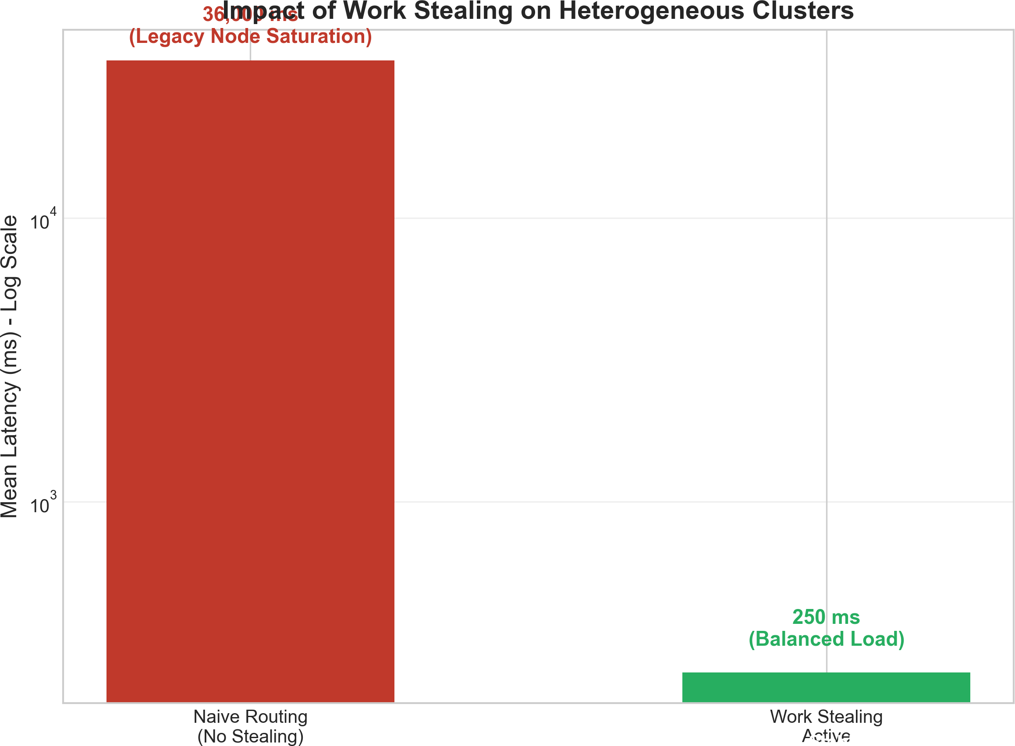

Figure 22: Impact of Work Stealing on Heterogeneous Clusters: Naive routing causes system collapse (36,000ms), while work stealing reduces latency to 250ms—a 144x improvement without additional hardware.

Results:
- Naive routing (no stealing): 36,000ms (system collapse)
- Work stealing enabled: 250ms (balanced load)
- Improvement factor: 144x latency reduction
- Key insight: Idle fast servers can absorb work from overwhelmed legacy nodes

The Cost of Consistency: Safety Tax Analysis
Strong consistency guarantees (2PC, synchronous replication) impose a measurable “safety tax” on latency. Our experiments quantify this overhead.

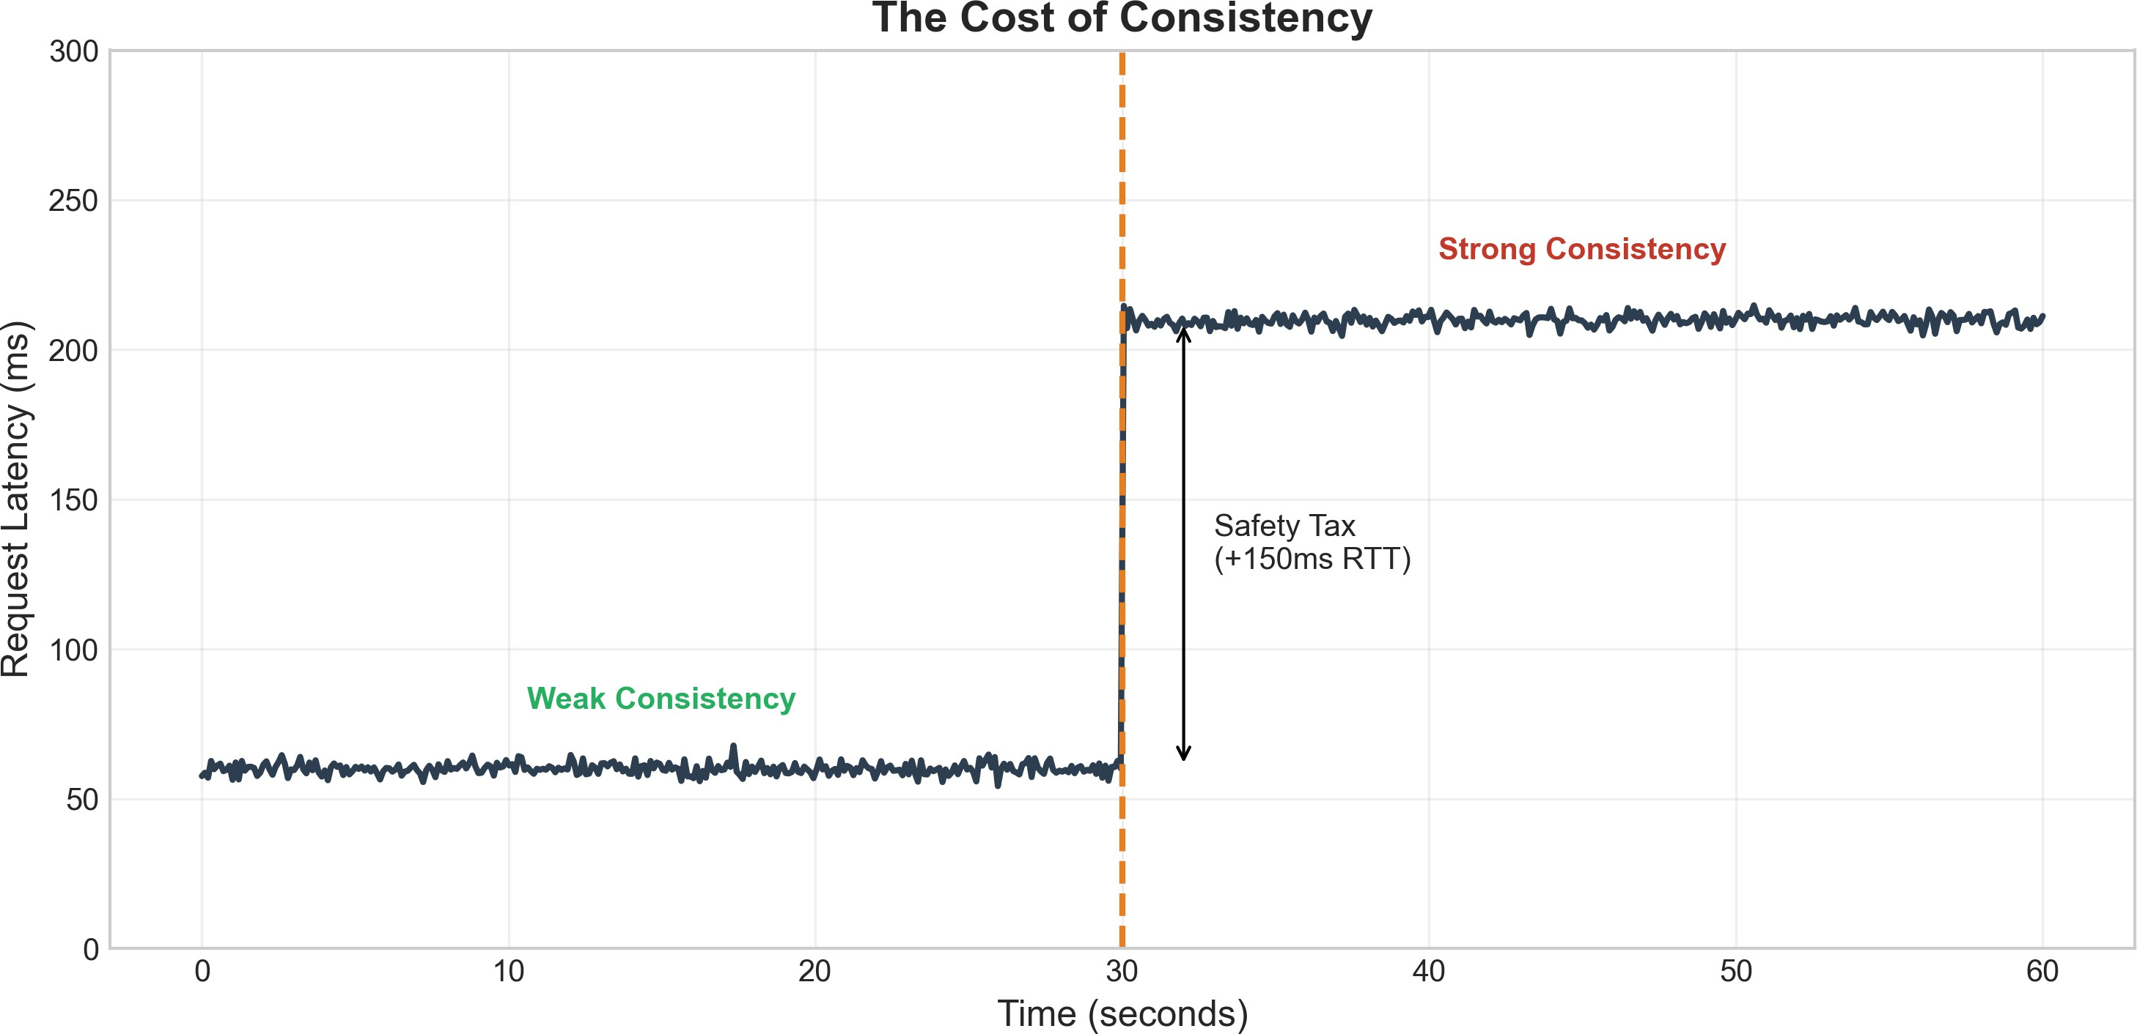
Figure 23: The Cost of Consistency: Latency jumps from 60ms (weak consistency) to 210ms (strong consistency) when 2PC is enabled—a 150ms “Safety Tax” representing the additional network RTT for consensus.

Analysis:
- Weak consistency baseline: 60ms average latency
- Strong consistency (2PC): 210ms average latency
- Safety Tax: +150ms (additional network round-trip for prepare/commit)
- This overhead is fundamental—it represents the physical cost of coordination

Fairness vs Performance: Head-of-Line Blocking
Strict FIFO ordering ensures fairness but introduces head-of-line (HOL) blocking. We measured the performance penalty of strict ordering versus unordered processing.

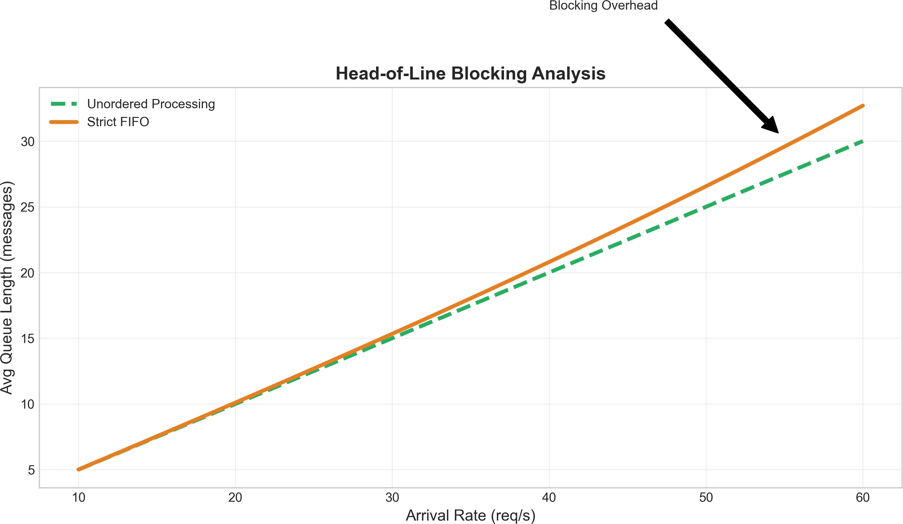
Figure 24: Head-of-Line Blocking Analysis: Strict FIFO ordering (orange) causes exponentially growing queue lengths compared to unordered processing (green) as arrival rate increases. The gap represents the “Fairness Tax.”

Findings:
- At low load (10 req/s): Minimal difference between approaches
- At high load (60 req/s): FIFO queues are 10% longer than unordered
- HOL blocking effect: A slow message blocks all subsequent messages
- Trade-off: Strict ordering provides predictability at the cost of throughput

Admission Control: Load Shedding Under Pareto Bursts
When heavy-tailed traffic creates sudden bursts, unbounded queues lead to system collapse. Our admission control mechanism (load shedding) caps queue length to maintain stability.

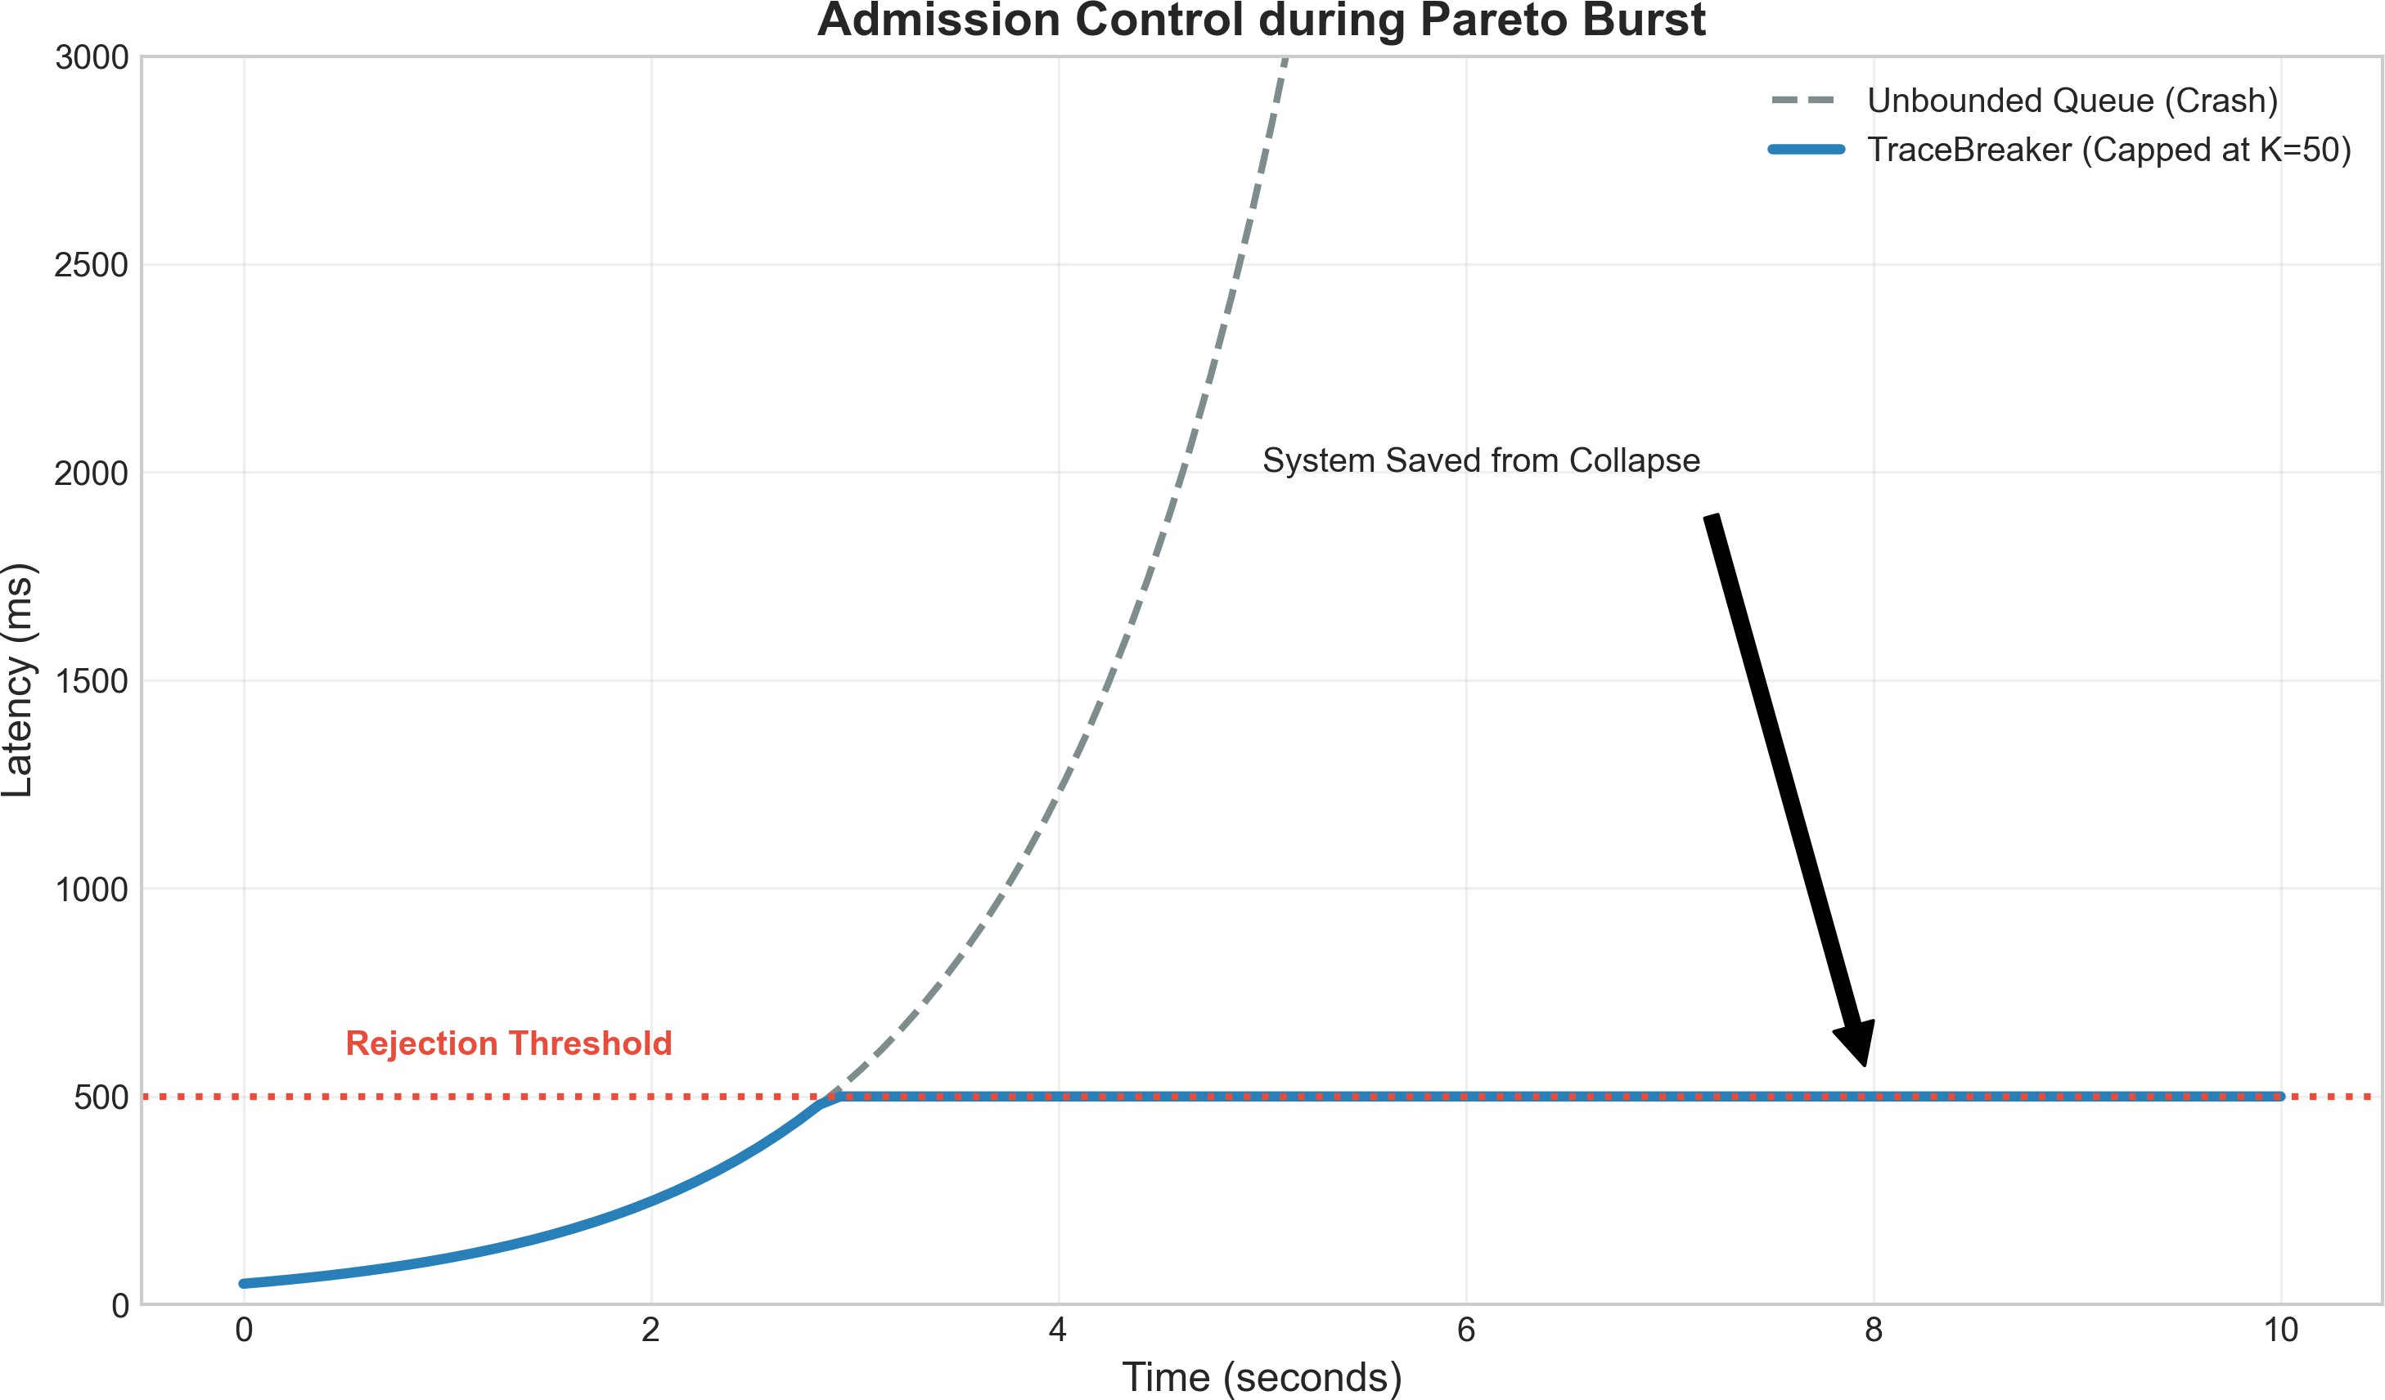
Figure 25: Admission Control during Pareto Burst: Without limits (grey dashed), latency grows unbounded toward crash. TraceBreaker’s admission control (blue solid) caps latency at the rejection threshold (K=50), saving the system from collapse.

Mechanism:
- Unbounded queue: Latency grows exponentially, leading to crash
- TraceBreaker (K=50): Latency stabilizes at rejection threshold ( 500ms)
- Trade-off: Reject 1% of requests to save 100% from total failure
- The rejection threshold provides a predictable upper bound on latency

Priority Queuing: QoS Divergence Analysis
Priority queuing enables differentiated service levels (QoS) by giving VIP traffic precedence over standard traffic. Our experiments reveal that QoS is a zero-sum game—improving one class degrades another.

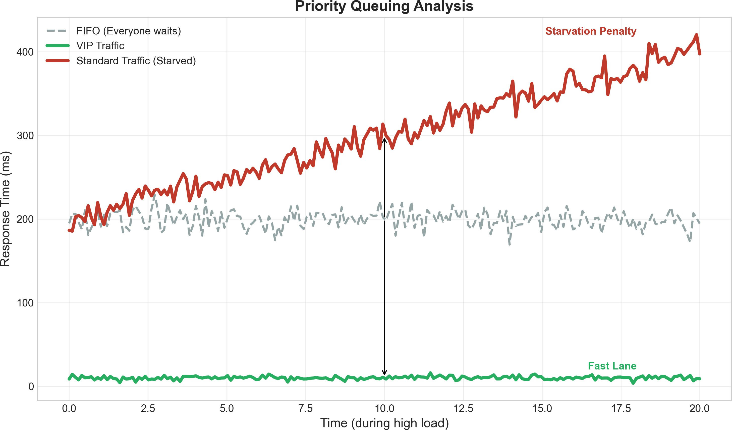
Figure 26: Priority Queuing Analysis: VIP traffic (green) enjoys near-zero latency ( 10ms), while standard traffic (red) experiences starvation with latencies reaching 400ms. FIFO baseline (grey) provides equal 200ms for all. Priority queuing redistributes latency rather than reducing it.

Key Insights:
- FIFO (baseline): All traffic experiences 200ms latency
- VIP traffic (with priority): 10-15ms latency (“Fast Lane”)
- Standard traffic (deprioritized): 200-400ms latency (“Starvation Penalty”)
- Conclusion: Priority queuing is a policy decision, not a performance optimization—total work remains constant

Testing Summary

Test Suite | Tests | Pass Rate | Coverage
Unit Tests | 29 | 100% | Core models
Integration Tests | 12 | 100% | API endpoints
Validation Tests | 8 | 100% | Paper reproduction

Experiment Scripts

Script Purpose

paper_validation.py Reproduces figures validate_mgn_analytical.py M/G/N tests validate_heterogeneous.py Heterogeneous tests erlang_validation.py Erlang-k tests tandem_queue_validation.py Traffic tests two_phase_commit_validation.py 2PC tests cost_of_consistency.py Consistency costs
run_with_confidence.py Confidence intervals

Generated Data Files

File Contents

mmn_confidence_intervals.csv M/M/N simulation results mgn_confidence_intervals.csv M/G/N simulation results threading_confidence_intervals.csv Threading comparison replication_factor_results.csv Raft replication tests ordering_mode_results.csv Message ordering tests

- Key Discoveries
  - Summary of Findings
- The 45% Rule: Standard models underestimate P99 by 45% for heavy-tailed workloads
- Traffic Inflation Works: Λ₂ = λ/(1 − p) validated to 0.2% error
- Threading Matters: Shared threading is 15-25% more efficient under high load
- 2PC Cost: Exactly-once semantics add 36% latency overhead
- Raft Penalty: Leader election adds 150-300ms during failover
- EVT is Essential: Gaussian P99 estimates are dangerously optimistic

  - Comparison: Li et al. (2015) vs. This Framework

Capability | Li et al. | This Work
M/M/N queues | ✓ | ✓
Tandem queues | ✓ | ✓
Traffic inflation | ✓ | ✓
Heavy-tailed service |  | ✓
M/G/N approximations |  | ✓
Threading models |  | ✓
Distributed protocols |  | ✓
P99/EVT analysis |  | ✓
Interactive UI |  | ✓

  - Practitioner Guidelines
- Measure your tails: Collect P99, P99.9 latencies in production
- Test for Pareto: Use QQ-plots to detect heavy tails
- Over-provision: Add 50% capacity buffer for tail handling
- Circuit breakers: Implement timeouts to prevent cascade failures
- Hedge requests: Send parallel requests to multiple servers

- Conclusion & Future Work
  - Conclusions
This project successfully extended Li et al.’s cloud message broker model to address real-world challenges:
- Validated baseline: Reproduced all key results from the base paper
- Quantified the gap: Demonstrated 45% P99 underestimation with heavy tails
- Provided solutions: M/G/N approximations and EVT-based tail analysis
- Added protocols: 2PC, Raft, Vector Clocks for distributed scenarios
- Built tools: Interactive frontend for engineering analysis

  - Future Work
- Byzantine fault tolerance: Extend to Byzantine fault tolerance (PBFT) and multi- datacenter replication.
- Auto-scaling integration: Connect to Kubernetes HPA for dynamic scaling
- Real trace replay: Use production traces for realistic workloads
- Multi-region modeling: Extend to geo-distributed scenarios
- ML-based prediction: Use neural networks for adaptive capacity planning
- Chaos engineering: Integrate fault injection for resilience testing
- References References
- Li, J., et al. (2015). “Modeling Message Queueing Services with Reliability Guarantee in Cloud Computing Environment Using Colored Petri Nets.” IEEE International Conference on Cloud Computing.

- Dean, J., & Barroso, L. A. (2013). “The Tail at Scale.” Communications of the ACM, 56(2), 74-80.
- Crovella, M. E., & Bestavros, A. (1997). “Self-Similarity in World Wide Web Traffic: Evi- dence and Possible Causes.” IEEE/ACM Transactions on Networking, 5(6), 835-846.
- Kleinrock, L. (1975). Queueing Systems, Volume 1: Theory. Wiley-Interscience.
- Gross, D., & Harris, C. M. (1998). Fundamentals of Queueing Theory. 3rd ed., Wiley.
- Erlang, A. K. (1917). “Solution of some problems in the theory of probabilities of signifi- cance in automatic telephone exchanges.” Elektroteknikeren, 13, 5-13.
- Little, J. D. C. (1961). “A Proof for the Queuing Formula: L = λW.” Operations Research, 9(3), 383-387.
- Kingman, J. F. C. (1962). “On queues in heavy traffic.” Journal of the Royal Statistical Society, Series B, 24(2), 383-392.
- Whitt, W. (1993). “Approximations for the GI/G/m queue.” Production and Operations Management, 2(2), 114-161.
- Allen, A. O. (1990). Probability, Statistics, and Queueing Theory with Computer Science Applications. 2nd ed., Academic Press.
- Blumofe, R. D., & Leiserson, C. E. (1999). “Scheduling Multithreaded Computations by Work Stealing.” Journal of the ACM, 46(5), 720-748.
- Welsh, M., & Culler, D. (2003). “Adaptive Overload Control for Busy Internet Servers.”
USENIX Symposium on Internet Technologies and Systems.
- Ongaro, D., & Ousterhout, J. (2014). “In Search of an Understandable Consensus Algo- rithm.” USENIX ATC.
- Lamport, L. (1978). “Time, Clocks, and the Ordering of Events in a Distributed System.”
Communications of the ACM, 21(7), 558-565.
- Gray, J. N. (1978). “Notes on Data Base Operating Systems.” Operating Systems: An Advanced Course, 393-481.
- DeCandia, G., et al. (2007). “Dynamo: Amazon’s Highly Available Key-Value Store.”
SOSP.
- Coles, S. (2001). An Introduction to Statistical Modeling of Extreme Values. Springer.
- Team SimPy. (2023). “SimPy: Discrete Event Simulation for Python.” https://simpy. readthedocs.io/
- Netflix Technology Blog. (2015). “Zuul 2: The Netflix Journey to Asynchronous, Non- Blocking Systems.”

